Table of Contents

UNITED STATES

SECURITIES AND EXCHANGE COMMISSION

Washington, D.C. 20549

_______________________

FORM 10-Q

- QUARTERLY REPORT PURSUANT TO SECTION 13 OR 15(d) OF THE SECURITIES EXCHANGE ACT OF 1934

FOR THE QUARTERLY PERIOD ENDED SEPTEMBER 30, 2025

OR

- TRANSITION REPORT PURSUANT TO SECTION 13 OR 15(d) OF THE SECURITIES EXCHANGE ACT OF 1934

FOR THE TRANSITION PERIOD FROM

Commission File Number 001-34223

_______________________
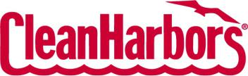

TO

CLEAN HARBORS, INC.

(Exact name of registrant as specified in its charter)

Massachusetts | 04-2997780
(State or Other Jurisdiction of Incorporation or Organization) | (IRS Employer Identification No.)
42 Longwater Drive Norwell MA | 02061-9149
(Address of Principal Executive Offices) | (Zip Code)

Registrant’s Telephone Number, Including area code: (781) 792-5000

Securities registered pursuant to Section 12(b) of the Act:

Title of each class |  | Trading Symbol |  | Name of each exchange on which registered
Common Stock, $0.01 par value |  | CLH |  | New York Stock Exchange

Indicate by check mark whether the registrant (1) has filed all reports required to be filed by Section 13 or 15(d) of the Securities Exchange Act of 1934 during the preceding 12 months (or for such shorter period that the registrant was required to file such reports) and (2) has been subject to such filing requirements for the past 90 days. Yes ☒ No ☐

Indicate by check mark whether the registrant has submitted electronically every Interactive Data File required to be submitted pursuant to Rule 405 of Regulation S-T during the preceding 12 months (or for such shorter period that the registrant was required to submit such files). Yes ☒ No ☐

Indicate by check mark whether the registrant is a large accelerated filer, an accelerated filer, a non-accelerated filer, a smaller reporting company, or an emerging growth company. See the definitions of “large accelerated filer,” “accelerated filer,” “smaller reporting company,” and “merging growth company” in Rule 12b-2 of the Exchange Act. (Check one):

Large accelerated filer

Non-accelerated filer

☒

☐

Accelerated filer ☐

Smaller reporting company ☐

Emerging growth company ☐

If an emerging growth company, indicate by check mark if the registrant has elected not to use the extended transition period for complying with any new or revised financial accounting standards provided pursuant to Section 13(a) of the Exchange Act. ☐

Indicate by check mark whether the registrant is a shell company (as defined by Rule 12b-2 of the Exchange Act). Yes ☐ No ☒ The number of shares of Common Stock, $0.01 par value, of the registrant outstanding at October 24, 2025 was 53,431,835.

 |  |  |  |  |  |  |  |  |  |  |  |  |  |  |  |  |  |  |  |  | CLEAN HARBORS, INC.
 |  |  |  |  |  |  |  |  |  |  |  |  |  |  |  |  |  |  | QUARTERLY REPORT ON FORM 10-Q
 |  |  |  |  |  |  |  |  |  |  |  |  |  |  |  |  |  |  |  |  | TABLE OF CONTENTS
 |  |  |  |  |  |  |  |  |  |  |  |  |  |  |  |  |  |  |  |  |  |  |  |  | Page No.
 |  |  |  |  |  |  |  |  |  |  |  |  |  |  |  |  |  |  | PART I: FINANCIAL INFORMATION
 | ITEM 1: Unaudited Consolidated Financial Statements
 |  | Consolidated Balance Sheets |  |  |  |  |  |  |  |  |  |  |  |  |  |  |  |  |  |  |  |  |  |  |  | 1
 |  | Unaudited Consolidated Statements of Operations |  |  |  |  |  |  |  |  |  |  |  |  |  |  |  |  |  |  |  |  |  |  |  | 2
 |  | Unaudited Consolidated Statements of Comprehensive Income |  |  |  |  |  |  |  |  |  |  |  |  |  |  |  |  |  |  |  |  |  |  |  | 3
 |  | Unaudited Consolidated Statements of Cash Flows |  |  |  |  |  |  |  |  |  |  |  |  |  |  |  |  |  |  |  |  |  |  |  | 4
 |  | Unaudited Consolidated Statements of Stockholders’ Equity |  |  |  |  |  |  |  |  |  |  |  |  |  |  |  |  |  |  |  |  |  |  | 5
 |  | Notes to Unaudited Consolidated Financial Statements |  |  |  |  |  |  |  |  |  |  |  |  |  |  |  |  |  |  |  |  |  |  |  | 7
 | ITEM 2: Management’s Discussion and Analysis of Financial Condition and Results of Operations |  |  |  |  |  |  |  |  |  |  |  |  |  |  |  |  |  |  |  |  |  |  |  | 24
 | ITEM 3: Quantitative and Qualitative Disclosures About Market Risk |  |  |  |  |  |  |  |  |  |  |  |  |  |  |  |  |  |  |  |  |  |  |  | 36
 | ITEM 4: Controls and Procedures |  |  |  |  |  |  |  |  |  |  |  |  |  |  |  |  |  |  |  |  |  |  |  | 36
 |  |  |  |  |  |  |  |  |  |  |  |  |  |  |  |  |  |  |  |  | PART II: OTHER INFORMATION
 | ITEM 1: Legal Proceedings |  |  |  |  |  |  |  |  |  |  |  |  |  |  |  |  |  |  |  |  |  |  |  | 38
 | ITEM 1A: Risk Factors |  |  |  |  |  |  |  |  |  |  |  |  |  |  |  |  |  |  |  |  |  |  |  | 38
 | ITEM 2: Unregistered Sales of Equity Securities and Use of Proceeds |  |  |  |  |  |  |  |  |  |  |  |  |  |  |  |  |  |  |  |  |  |  |  | 38
 | ITEM 3: Defaults Upon Senior Securities |  |  |  |  |  |  |  |  |  |  |  |  |  |  |  |  |  |  |  |  |  |  |  | 38
 | ITEM 4: Mine Safety Disclosures |  |  |  |  |  |  |  |  |  |  |  |  |  |  |  |  |  |  |  |  |  |  |  | 38
 | ITEM 5: Other Information |  |  |  |  |  |  |  |  |  |  |  |  |  |  |  |  |  |  |  |  |  |  |  | 38
 | ITEM 6: Exhibits |  |  |  |  |  |  |  |  |  |  |  |  |  |  |  |  |  |  |  |  |  |  |  | 39
 | Signatures |  |  |  |  |  |  |  |  |  |  |  |  |  |  |  |  |  |  |  |  |  |  |  | 40

Table of Contents

CLEAN HARBORS, INC. AND SUBSIDIARIES

CONSOLIDATED BALANCE SHEETS

(in thousands)

 |  | September 30, 2025 |  |  | December 31, 2024
ASSETS |  | (unaudited)
Current assets:
Cash and cash equivalents | $ | 759,197 |  | $ | 687,192
Short-term marketable securities |  | 91,176 |  |  | 102,634
Accounts receivable, net of allowances aggregating $43,778 and $47,242, respectively |  | 1,104,805 |  |  | 1,015,357
Unbilled accounts receivable |  | 182,059 |  |  | 162,215
Inventories and supplies |  | 377,308 |  |  | 384,657
Prepaid expenses and other current assets |  | 93,716 |  |  | 81,741
Total current assets |  | 2,608,261 |  |  | 2,433,796
Property, plant and equipment, net |  | 2,497,600 |  |  | 2,447,941
Other assets:
Operating lease right-of-use assets |  | 241,048 |  |  | 250,853
Goodwill |  | 1,478,831 |  |  | 1,477,199
Permits and other intangibles, net |  | 663,965 |  |  | 701,987
Other long-term assets |  | 50,594 |  |  | 65,502
Total other assets |  | 2,434,438 |  |  | 2,495,541
Total assets | $ | 7,540,299 |  | $ | 7,377,278
LIABILITIES AND STOCKHOLDERS’ EQUITY
Current liabilities:
Current portion of long-term debt | $ | 15,102 |  | $ | 15,102
Accounts payable |  | 444,119 |  |  | 487,286
Deferred revenue |  | 91,966 |  |  | 88,545
Accrued expenses and other current liabilities |  | 415,170 |  |  | 419,445
Current portion of closure, post-closure and remedial liabilities |  | 28,814 |  |  | 20,625
Current portion of operating lease liabilities |  | 72,241 |  |  | 71,663
Total current liabilities |  | 1,067,412 |  |  | 1,102,666
Other liabilities:
Closure and post-closure liabilities, less current portion of $16,796 and $10,304, respectively |  | 122,546 |  |  | 119,484
Remedial liabilities, less current portion of $12,018 and $10,321, respectively |  | 85,299 |  |  | 101,424
Long-term debt, less current portion |  | 2,764,231 |  |  | 2,771,117
Operating lease liabilities, less current portion |  | 173,137 |  |  | 182,883
Deferred tax liabilities |  | 358,597 |  |  | 363,623
Other long-term liabilities |  | 193,237 |  |  | 162,552
Total other liabilities |  | 3,697,047 |  |  | 3,701,083
Commitments and contingent liabilities (See Note 15)
Stockholders’ equity:
Common stock, $0.01 par value:
Authorized 80,000,000 shares; issued and outstanding 53,430,975 and 53,832,692 shares, respectively |  | 534 |  |  | 538
Additional paid-in capital |  | 317,145 |  |  | 421,749
Accumulated other comprehensive loss |  | (211,100) |  |  | (213,635)
Retained earnings |  | 2,669,261 |  |  | 2,364,877
Total stockholders’ equity |  | 2,775,840 |  |  | 2,573,529
Total liabilities and stockholders’ equity | $ | 7,540,299 |  | $ | 7,377,278

The accompanying notes are an integral part of these unaudited consolidated financial statements.

1

Table of Contents

CLEAN HARBORS, INC. AND SUBSIDIARIES

UNAUDITED CONSOLIDATED STATEMENTS OF OPERATIONS

(in thousands, except per share amounts)

 |  | Three Months Ended |  |  |  |  |  | Nine Months Ended
 |  | September 30, |  |  |  |  |  | September 30,
 |  | 2025 |  |  | 2024 |  |  | 2025 |  |  | 2024
Revenues:
Service revenues | $ | 1,321,865 |  | $ | 1,278,955 |  | $ | 3,860,267 |  | $ | 3,719,183
Product revenues |  | 227,472 |  |  | 250,467 |  |  | 670,874 |  |  | 739,653
Total revenues |  | 1,549,337 |  |  | 1,529,422 |  |  | 4,531,141 |  |  | 4,458,836
Cost of revenues: (exclusive of items shown separately below)
Service revenues |  | 873,744 |  |  | 872,829 |  |  | 2,588,407 |  |  | 2,539,569
Product revenues |  | 174,746 |  |  | 182,770 |  |  | 515,464 |  |  | 522,642
Total cost of revenues |  | 1,048,490 |  |  | 1,055,599 |  |  | 3,103,871 |  |  | 3,062,211
Selling, general and administrative expenses |  | 189,610 |  |  | 177,846 |  |  | 558,640 |  |  | 557,590
Accretion of environmental liabilities |  | 3,499 |  |  | 3,618 |  |  | 10,710 |  |  | 10,139
Depreciation and amortization |  | 114,729 |  |  | 100,063 |  |  | 342,994 |  |  | 295,632
Income from operations |  | 193,009 |  |  | 192,296 |  |  | 514,926 |  |  | 533,264
Other income (expense), net |  | 3,517 |  |  | (1,123) |  |  | 1,982 |  |  | (2,431)
Interest expense, net of interest income of $6,497, $5,391, $17,212 and $13,257, respectively |  | (35,700) |  |  | (35,779) |  |  | (108,883) |  |  | (100,767)
Income before provision for income taxes |  | 160,826 |  |  | 155,394 |  |  | 408,025 |  |  | 430,066
Provision for income taxes |  | 42,027 |  |  | 40,181 |  |  | 103,641 |  |  | 111,741
Net income | $ | 118,799 |  | $ | 115,213 |  | $ | 304,384 |  | $ | 318,325
Earnings per share:
Basic | $ | 2.22 |  | $ | 2.14 |  | $ | 5.67 |  | $ | 5.90
Diluted | $ | 2.21 |  | $ | 2.12 |  | $ | 5.65 |  | $ | 5.87
Shares used to compute earnings per share - Basic |  | 53,518 |  |  | 53,951 |  |  | 53,659 |  |  | 53,936
Shares used to compute earnings per share - Diluted |  | 53,713 |  |  | 54,229 |  |  | 53,871 |  |  | 54,229

The accompanying notes are an integral part of these unaudited consolidated financial statements.

2

Table of Contents

CLEAN HARBORS, INC. AND SUBSIDIARIES

UNAUDITED CONSOLIDATED STATEMENTS OF COMPREHENSIVE INCOME

(in thousands)

 |  | Three Months Ended |  |  |  |  |  | Nine Months Ended
 |  | September 30, |  |  |  |  |  | September 30,
 |  | 2025 |  |  | 2024 |  |  | 2025 |  |  | 2024
Net income | $ | 118,799 |  | $ | 115,213 |  | $ | 304,384 |  | $ | 318,325
Other comprehensive (loss) income, net of tax:
Unrealized gain on available-for-sale securities |  | 69 |  |  | 262 |  |  | 164 |  |  | 170
Unrealized gain (loss) on fair value of interest rate hedges |  | 524 |  |  | (9,361) |  |  | (3,953) |  |  | 2,406
Reclassification adjustment for interest rate hedge amounts realized in net income |  | (2,630) |  |  | (3,806) |  |  | (7,823) |  |  | (11,260)
Pension adjustments |  | 13 |  |  | (10) |  |  | (20) |  |  | 18
Foreign currency translation adjustments |  | (10,547) |  |  | 5,369 |  |  | 14,167 |  |  | (8,031)
Other comprehensive (loss) income, net of tax |  | (12,571) |  |  | (7,546) |  |  | 2,535 |  |  | (16,697)
Comprehensive income | $ | 106,228 |  | $ | 107,667 |  | $ | 306,919 |  | $ | 301,628

The accompanying notes are an integral part of these unaudited consolidated financial statements.

3

Table of Contents

CLEAN HARBORS, INC. AND SUBSIDIARIES

UNAUDITED CONSOLIDATED STATEMENTS OF CASH FLOWS

(in thousands)

 |  | Nine Months Ended
 |  | September 30,
 |  | 2025 |  |  | 2024
Cash flows from operating activities:
Net income | $ | 304,384 |  | $ | 318,325
Adjustments to reconcile net income to net cash from operating activities:
Depreciation and amortization |  | 342,994 |  |  | 295,632
Allowance for doubtful accounts |  | 6,520 |  |  | 5,674
Amortization of deferred financing costs and debt discount |  | 5,024 |  |  | 4,623
Accretion of environmental liabilities |  | 10,710 |  |  | 10,139
Changes in environmental liability estimates |  | (8,933) |  |  | 4,347
Deferred income taxes |  | — |  |  | (418)
Other (income) expense, net |  | (1,982) |  |  | 2,431
Stock-based compensation |  | 22,620 |  |  | 20,690
Environmental expenditures |  | (10,960) |  |  | (19,679)
Changes in assets and liabilities, net of acquisitions:
Accounts receivable and unbilled accounts receivable |  | (113,131) |  |  | (145,647)
Inventories and supplies |  | 8,301 |  |  | (39,673)
Other current and long-term assets |  | (5,467) |  |  | (47,826)
Accounts payable |  | (35,492) |  |  | 30,004
Other current and long-term liabilities |  | (12,956) |  |  | 35,211
Net cash from operating activities |  | 511,632 |  |  | 473,833
Cash flows used in investing activities:
Additions to property, plant and equipment |  | (303,169) |  |  | (369,826)
Proceeds from sale and disposal of fixed assets |  | 15,250 |  |  | 6,353
Acquisitions, net of cash acquired |  | — |  |  | (474,011)
Proceeds from sale of business |  | — |  |  | 750
Additions to intangible assets including costs to obtain or renew permits |  | (1,528) |  |  | (2,545)
Purchases of available-for-sale securities |  | (62,108) |  |  | (73,682)
Proceeds from sale of available-for-sale securities |  | 74,968 |  |  | 100,021
Net cash used in investing activities |  | (276,587) |  |  | (812,940)
Cash flows (used in) from financing activities:
Change in uncashed checks |  | (2,639) |  |  | (5,852)
Tax payments related to withholdings on vested restricted stock |  | (13,833) |  |  | (11,514)
Repurchases of common stock |  | (117,001) |  |  | (30,215)
Proceeds from employee stock purchase plan |  | 3,360 |  |  | —
Deferred financing costs paid |  | — |  |  | (8,316)
Payments on finance leases |  | (25,088) |  |  | (23,596)
Principal payments on debt |  | (11,327) |  |  | (11,327)
Proceeds from issuance of debt, net of discount |  | — |  |  | 499,375
Net cash (used in) from financing activities |  | (166,528) |  |  | 408,555
Effect of exchange rate change on cash |  | 3,488 |  |  | (1,775)
Increase in cash and cash equivalents |  | 72,005 |  |  | 67,673
Cash and cash equivalents, beginning of period |  | 687,192 |  |  | 444,698
Cash and cash equivalents, end of period | $ | 759,197 |  | $ | 512,371
Supplemental information:
Cash payments for interest and income taxes:
Interest paid | $ | 133,520 |  | $ | 134,177
Income taxes paid, net of refunds |  | 93,531 |  |  | 100,752
Non-cash investing activities:
Property, plant and equipment accrued |  | 36,604 |  |  | 43,604
ROU assets obtained in exchange for operating lease liabilities |  | 51,736 |  |  | 98,927
ROU assets obtained in exchange for finance lease liabilities |  | 59,937 |  |  | 53,391

The accompanying notes are an integral part of these unaudited consolidated financial statements.

4

Table of Contents

CLEAN HARBORS, INC. AND SUBSIDIARIES

UNAUDITED CONSOLIDATED STATEMENTS OF STOCKHOLDERS’ EQUITY

(in thousands)

 | Common Stock
 | Number |  |  | $0.01 |  |  | Additional |  |  | Accumulated |  |  |  |  |  | Total
 | of |  |  | Par |  |  | Paid-in |  |  | Other |  |  | Retained Earnings |  |  | Stockholders’
 | Shares |  |  | Value |  |  | Capital |  |  | Comprehensive Loss |  |  |  |  |  | Equity
Balance at January 1, 2025 | 53,833 |  | $ | 538 |  | $ | 421,749 |  | $ | (213,635) |  | $ | 2,364,877 |  | $ | 2,573,529
Net income | — |  |  | — |  |  | — |  |  | — |  |  | 58,680 |  |  | 58,680
Other comprehensive loss | — |  |  | — |  |  | — |  |  | (4,932) |  |  | — |  |  | (4,932)
Stock-based compensation | — |  |  | — |  |  | 7,635 |  |  | — |  |  | — |  |  | 7,635
Issuance of common stock for restricted share vesting, net of
employee tax withholdings | 59 |  |  | 1 |  |  | (8,689) |  |  | — |  |  | — |  |  | (8,688)
Repurchases of common stock | (256) |  |  | (3) |  |  | (54,997) |  |  | — |  |  | — |  |  | (55,000)
Balance at March 31, 2025 | 53,636 |  |  | 536 |  |  | 365,698 |  |  | (218,567) |  |  | 2,423,557 |  |  | 2,571,224
Net income | — |  |  | — |  |  | — |  |  | — |  |  | 126,905 |  |  | 126,905
Other comprehensive income | — |  |  | — |  |  | — |  |  | 20,038 |  |  | — |  |  | 20,038
Stock-based compensation | — |  |  | — |  |  | 6,063 |  |  | — |  |  | — |  |  | 6,063
Issuance of common stock for restricted share vesting, net of
employee tax withholdings | 24 |  |  | — |  |  | (1,768) |  |  | — |  |  | — |  |  | (1,768)
Repurchases of common stock | (62) |  |  | — |  |  | (11,755) |  |  | — |  |  | — |  |  | (11,755)
Employee stock purchase plan | 16 |  |  | — |  |  | 3,360 |  |  | — |  |  | — |  |  | 3,360
Balance at June 30, 2025 | 53,614 |  |  | 536 |  |  | 361,598 |  |  | (198,529) |  |  | 2,550,462 |  |  | 2,714,067
Net income | — |  |  | — |  |  | — |  |  | — |  |  | 118,799 |  |  | 118,799
Other comprehensive loss | — |  |  | — |  |  | — |  |  | (12,571) |  |  | — |  |  | (12,571)
Stock-based compensation | — |  |  | — |  |  | 8,922 |  |  | — |  |  | — |  |  | 8,922
Issuance of common stock for restricted share vesting, net of
employee tax withholdings | 25 |  |  | — |  |  | (3,377) |  |  | — |  |  | — |  |  | (3,377)
Repurchases of common stock | (208) |  |  | (2) |  |  | (49,998) |  |  | — |  |  | — |  |  | (50,000)
Balance at September 30, 2025 | 53,431 |  | $ | 534 |  | $ | 317,145 |  | $ | (211,100) |  | $ | 2,669,261 |  | $ | 2,775,840

5

Table of Contents

CLEAN HARBORS, INC. AND SUBSIDIARIES

UNAUDITED CONSOLIDATED STATEMENTS OF STOCKHOLDERS’ EQUITY (CONTINUED)

(in thousands)

 | Common Stock |  |  |  |  |  |  |  |  | Accumulated
 | Number |  |  | $0.01 |  |  | Additional |  |  |  |  |  |  |  |  | Total
 |  |  |  | $0.01 |  |  |  |  |  | Other |  |  |  |  |  | Total
 | of |  |  | Par |  |  | Paid-in |  |  | Comprehensive |  |  | Retained Earnings |  |  | Stockholders’
 | Shares |  |  | Value |  |  | Capital |  |  | Loss |  |  |  |  |  | Equity
Balance at January 1, 2024 | 53,930 |  | $ | 539 |  | $ | 459,728 |  | $ | (175,339) |  | $ | 1,962,578 |  | $ | 2,247,506
Net income | — |  |  | — |  |  | — |  |  | — |  |  | 69,832 |  |  | 69,832
Other comprehensive loss | — |  |  | — |  |  | — |  |  | (4,287) |  |  | — |  |  | (4,287)
Stock-based compensation | — |  |  | — |  |  | 6,338 |  |  | — |  |  | — |  |  | 6,338
Issuance of common stock for restricted share vesting, net of
employee tax withholdings | 23 |  |  | — |  |  | (3,052) |  |  | — |  |  | — |  |  | (3,052)
Repurchases of common stock | (27) |  |  | — |  |  | (5,000) |  |  | — |  |  | — |  |  | (5,000)
Balance at March 31, 2024 | 53,926 |  |  | 539 |  |  | 458,014 |  |  | (179,626) |  |  | 2,032,410 |  |  | 2,311,337
Net income | — |  |  | — |  |  | — |  |  | — |  |  | 133,280 |  |  | 133,280
Other comprehensive loss | — |  |  | — |  |  | — |  |  | (4,864) |  |  | — |  |  | (4,864)
Stock-based compensation | — |  |  | — |  |  | 8,515 |  |  | — |  |  | — |  |  | 8,515
Issuance of common stock for restricted share vesting, net of
employee tax withholdings | 27 |  |  | — |  |  | (1,547) |  |  | — |  |  | — |  |  | (1,547)
Repurchases of common stock | (23) |  |  | — |  |  | (5,000) |  |  | — |  |  | — |  |  | (5,000)
Balance at June 30, 2024 | 53,930 |  |  | 539 |  |  | 459,982 |  |  | (184,490) |  |  | 2,165,690 |  |  | 2,441,721
Net income | — |  |  | — |  |  | — |  |  | — |  |  | 115,213 |  |  | 115,213
Other comprehensive loss | — |  |  | — |  |  | — |  |  | (7,546) |  |  | — |  |  | (7,546)
Stock-based compensation | — |  |  | — |  |  | 5,837 |  |  | — |  |  | — |  |  | 5,837
Issuance of common stock for restricted share vesting, net of
employee tax withholdings | 54 |  |  | 1 |  |  | (6,916) |  |  | — |  |  | — |  |  | (6,915)
Repurchases of common stock | (85) |  |  | (1) |  |  | (19,999) |  |  | — |  |  | — |  |  | (20,000)
Balance at September 30, 2024 | 53,899 |  | $ | 539 |  | $ | 438,904 |  | $ | (192,036) |  | $ | 2,280,903 |  | $ | 2,528,310

The accompanying notes are an integral part of these unaudited consolidated financial statements.

6

Table of Contents

CLEAN HARBORS, INC. AND SUBSIDIARIES

NOTES TO UNAUDITED CONSOLIDATED FINANCIAL STATEMENTS

(1) BASIS OF PRESENTATION

The accompanying consolidated interim financial statements are unaudited and include the accounts of Clean Harbors, Inc. and its subsidiaries (collectively, “Clean Harbors” or the “Company”) and have been prepared pursuant to the rules and regulations of the Securities and Exchange Commission (the “SEC”) and, in the opinion of management, include all adjustments which are of a normal recurring nature and are necessary for a fair presentation of the financial position, results of operations and cash flows for the periods presented. Management has made estimates and assumptions affecting the amounts reported in the Company’s consolidated interim financial statements and accompanying footnotes; actual results could differ from those estimates and judgments.

The results for interim periods are not necessarily indicative of results for the entire year or any other interim periods. The financial statements presented herein should be read in conjunction with the financial statements included in the Company’s Annual Report on Form 10-K for the year ended December 31, 2024.

(2) SIGNIFICANT ACCOUNTING POLICIES

The Company’s significant accounting policies are described in Note 2, “Significant Accounting Policies,” in the Company's Annual Report on Form 10-K for the year ended December 31, 2024, and remain the same other than as noted below:

Income Taxes

On July 4, 2025, the One Big Beautiful Bill Act (the “Act”) was signed into law in the United States. The Act includes significant provisions, such as the permanent extension of key elements of the Tax Cuts and Jobs Act, including 100% bonus depreciation for qualified assets and domestic research cost expensing, as well as certain international tax changes. Accounting Standards Codification 740, “Income Taxes,” requires the effects of changes in tax laws to be recognized in the period in which the legislation is enacted. Many of the tax provisions of the Act are designed to accelerate tax deductions, which could lead to lower cash tax payments. The new tax provisions have multiple effective dates, with certain provisions effective in 2025 and others in future periods. The Company is still assessing the full impact of these tax law changes on its consolidated financial statements; however, the Company currently does not expect the Act to have a material impact on its financial position, results of operations or cash flows.

Recent Accounting Pronouncements

Accounting Pronouncements Adopted

In November 2023, the Financial Accounting Standards Board (the “FASB”) issued Accounting Standards Update (“ASU”) No. 2023-07, Segment Reporting (Topic 280): Improvements to Reportable Segment Disclosures, which requires an enhanced disclosure of significant segment expenses on an annual and interim basis. The Company adopted ASU No. 2023-07 for the year ended December 31, 2024. The only significant impact from the adoption of this standard relates to incremental disclosures now required. See Note 16 for applicable reportable segment disclosures required by this guidance.

Accounting Pronouncements Not Yet Adopted

In December 2023, the FASB issued ASU No. 2023-09, Income Taxes (Topic 740): Improvements to Income Tax Disclosures, which enhances income tax disclosures related to the tax rate reconciliation and income taxes paid. This guidance will be effective for annual periods beginning the year ended December 31, 2025. Early adoption is permitted. Upon adoption, the guidance can be applied prospectively or retrospectively. The requirements of this ASU are disclosure-related and are not expected to have an impact on the Company’s financial condition, results of operations or cash flows. The Company is currently evaluating the impact of adopting this new pronouncement on its income tax disclosures.

In November 2024, the FASB issued ASU No. 2024-03, Income Statement—Reporting Comprehensive

Income—Expense Disaggregation Disclosures (Subtopic 220-40): Disaggregation of Income Statement Expenses, which requires disaggregated disclosure of income statement expenses. This guidance will be effective for annual periods beginning the year ended December 31, 2027. Early adoption is permitted. Upon adoption, the guidance can be applied prospectively or retrospectively. The Company is currently evaluating the impact of adopting this new pronouncement on its consolidated financial statement disclosures.

In September 2025, the FASB issued ASU No. 2025-06, Intangibles—Goodwill and Other—Internal-Use Software (Subtopic 350-40): Targeted Improvements to the Accounting for Internal-Use Software, which is intended to modernize the accounting for internal-use software costs. The amendment eliminates the previous accounting model based on software development stages and aligns with current agile implementation principles. Under the new guidance, capitalization begins when management has

7

Table of Contents

authorized and committed to funding the project, and it is probable that the software will be completed and used for its intended purpose. The amendments are effective in annual periods beginning after December 15, 2027, and interim periods within those years, with early adoption permitted. The amendment may be applied on a prospective, retrospective or modified retrospective basis. The Company is currently evaluating the provisions of the amendments and the impact on its future consolidated statements.

(3) REVENUES

The Company generates revenues through the following operating segments: Environmental Services and Safety-Kleen Sustainability Solutions (“SKSS”). The Company’s Environmental Services operating segment generally has four sources of revenue, and the SKSS operating segment has two sources of revenue. The Company disaggregates third-party revenues by geographic location and source of revenue as management believes these categories depict how revenue and cash flows are affected by economic factors. The tables below present revenue billed to outside customers by a particular segment. Should it be necessary, there will be intercompany transactions to present the direct revenues in the appropriate segment results. The Company’s significant sources of revenue include:

Technical Services—Technical Services contribute to the revenues of the Environmental Services operating segment. Revenues for these services are generated from fees charged for waste material management and disposal services including onsite environmental management services, remediation projects, collection and transportation, packaging, recycling, treatment and disposal of waste. These services handle hazardous and/or non-hazardous waste, including per- and polyfluoroalkyl substances (“PFAS”). Revenue is primarily generated by short-term projects, most of which are governed by master service agreements that are long-term in nature and outline the pricing and legal frameworks for such arrangements. Services are provided based on purchase orders or agreements with the customer and include prices based upon units of volume of waste, material and personnel costs as well as transportation and other fees. Collection and transportation revenues are recognized over time, as the customer receives and consumes the benefits of the services as they are being performed and the Company has a right to payment for performance completed to date. The Company uses the input method to recognize revenue over time, based on time and materials incurred as a basis for measuring the satisfaction of the performance obligation. Revenues for treatment and disposal of waste are recognized upon completion of treatment, final disposition, or when the waste is shipped to a third-party for processing and disposal. The Company periodically enters into bundled arrangements for the collection and transportation and disposal of waste. For such arrangements, transportation and disposal are considered distinct performance obligations and the Company allocates revenue to each based on the relative standalone selling price (i.e., the estimated price that a customer would pay for the services on a standalone basis). Revenues and the related costs from waste that is not yet completely processed and disposed of are deferred. The deferred revenues and costs are recognized when the services are completed. The period between collection and transportation and the final processing and disposal ranges depending on the location of the customer, but generally is measured in days.

Industrial Services—Industrial Services contribute to the revenues of the Environmental Services operating segment. These revenues are primarily generated from industrial and specialty services provided to refineries, chemical plants, manufacturing facilities, power generation companies and other industrial customers throughout North America. Services include in-plant cleaning and maintenance services, plant outage and turnaround services, specialty cleaning services including chemical cleaning, pigging and high and ultra-high pressure water cleaning, leak detection and repair, daylighting, production services and upstream energy services. Services are provided based on purchase orders or agreements with the customer and include prices based upon daily, hourly or job rates for equipment, materials and personnel. The Company recognizes revenue for these services over time, as the customer receives and consumes the benefits of the services as they are being performed and the Company has a right to payment for performance completed to date. The Company uses the input method to recognize revenue over time, based on time and materials incurred.

Field and Emergency Response Services—Field and Emergency Response Services, which includes contributions from Hepaco Blocker, Inc. and its subsidiaries (collectively, “HEPACO”) since its acquisition on March 22, 2024, contribute to the revenues of the Environmental Services operating segment. Field Services revenues are generated from cleanup services at customer sites, including those managed by municipalities and utility providers, or other locations on a scheduled or emergency response basis. Services include confined space entry for tank cleaning, site decontamination, environmental remediation, railcar cleaning, manhole/vault clean outs, product recovery and transfer and vacuum services. Additional services include filtration, water treatment services and wetland restoration. Response services for environmental emergencies of any scale range from man-made disasters such as oil spills to natural disasters like hurricanes. Emergency response services also include spill cleanup on land and water, as well as contagion disinfection, decontamination and disposal services. Field and emergency response services are provided based on purchase orders or agreements with customers and include prices generally based upon daily, hourly or job rates for equipment, materials and personnel. The Company recognizes revenue for these services over time, as the customer receives and consumes the benefits of the services as they are being performed and the Company has a right to payment for performance completed to date. The Company uses the input method to recognize revenue over time, based on time and materials incurred. The duration of such services can be over a number of hours, several days or even months for larger scale projects.

8

Table of Contents

Safety-Kleen Environmental Services—Safety-Kleen Environmental Services revenues contribute both to the Environmental Services operating segment and the SKSS operating segment. Revenues from providing containerized waste handling and disposal services, parts washer services and vacuum services, referred to collectively as the Safety-Kleen branches’ core service offerings, contribute to the revenues of the Environmental Services operating segment. In addition, sales of packaged blended oil products and other complementary product sales contribute to the revenues of the Environmental Services operating segment. Revenues generated from waste oil, anti-freeze and oil filter collection services, sales of bulk blended oil products and sales of bulk automotive fluids contribute to the SKSS operating segment. Due to the complementary nature of these products and services and their customer base, there are some cross-overs of Safety-Kleen Environmental Services revenue streams between the Environmental Services and SKSS operating segments.

Generally, the revenue from services is recognized over time, as the customer receives and consumes the benefits of the services as they are being performed and the Company has a right to payment for performance completed to date. The duration of such services can be over a number of hours or several days. The Company uses the input method to recognize revenue over time, based on time and materials incurred. Product revenue is recognized upon the transfer of control whereby control transfers when the products are delivered to the customer. Containerized waste services consist of profiling, collecting, transporting and recycling or disposing of a wide variety of waste. Related collection and transportation revenues are recognized over time, as the customer receives and consumes the benefits of the services as they are being performed and the Company has a right to payment for performance completed to date. Parts washer services include customer use of the Company’s parts washer equipment, cleaning and maintenance of the parts washer equipment and removal and replacement of used cleaning fluids. Parts washer services are considered a single performance obligation due to the highly integrated and interdependent nature of the arrangement. Revenue from parts washer services is recognized over the service interval as the customer receives the benefit of the services.

Safety-Kleen Oil—Safety-Kleen Oil-related sales contribute to the revenues of the SKSS segment. These revenues are generated from bulk sales of high-quality base and blended lubricating oils to many industries, including major oil brands, lubricant blenders and manufacturers, blended lubricant distributors and government agencies. The business also sells recycled fuel oil to asphalt plants, industrial plants and pulp and paper companies. The used oil is also processed into vacuum gas oil which can be further re-refined into lubricant base oils or sold directly into the marine diesel oil fuel market. By-products coming off the refinery are a mixture of light end distillates and asphalt flux that are sold into various markets. Revenue for oil products is recognized at a point in time, upon the transfer of control. Generally, control transfers when the products are delivered to the customer.

The following tables present the Company’s third-party revenue disaggregated by source of revenue and geography (in thousands):

 |  |  |  |  |  |  |  | Three Months Ended September 30, 2025
 |  |  |  |  | Environmental Services |  | Safety-Kleen Sustainability |  |  | Corporate |  |  |  | Total
 |  |  |  |  |  |  |  | Solutions |  | Corporate |  |  |  | Total
 | Primary Geographical Markets
 | United States |  |  | $ | 1,194,300 |  | $ | 202,483 |  | $ | — |  | $ | 1,396,783
 | Canada |  |  |  | 124,280 |  |  | 28,274 |  |  | — |  |  | 152,554
 | Total third-party revenues |  |  | $ | 1,318,580 |  | $ | 230,757 |  | $ | — |  | $ | 1,549,337
 | Sources of Revenue
 | Technical Services |  |  | $ | 490,768 |  | $ | — |  | $ | — |  | $ | 490,768
 | Industrial Services |  |  |  | 332,102 |  |  | — |  |  | — |  |  | 332,102
 | Field and Emergency Response Services |  |  |  | 232,262 |  |  | — |  |  | — |  |  | 232,262
 | Safety-Kleen Environmental Services |  |  |  | 263,448 |  |  | 76,601 |  |  | — |  |  | 340,049
 | Safety-Kleen Oil |  |  |  | — |  |  | 154,156 |  |  | — |  |  | 154,156
 | Total third-party revenues |  |  | $ | 1,318,580 |  | $ | 230,757 |  | $ | — |  | $ | 1,549,337

9

Table of Contents

 |  |  |  |  |  |  |  |  |  |  | Three Months Ended September 30, 2024
 |  |  |  |  |  | Environmental Services |  |  |  | Safety-Kleen Sustainability |  |  |  |  | Corporate |  |  |  |  | Total
 |  |  |  |  |  |  |  |  |  |  | Solutions |  |  |  | Corporate |  |  |  |  | Total
 | Primary Geographical Markets
 | United States |  |  | $ |  | 1,166,660 |  |  | $ |  | 218,963 |  |  | $ |  | 96 |  |  | $ | 1,385,719
 | Canada |  |  |  |  | 120,990 |  |  |  |  | 22,713 |  |  |  |  | — |  |  |  | 143,703
 | Total third-party revenues |  |  | $ |  | 1,287,650 |  |  | $ |  | 241,676 |  |  | $ |  | 96 |  |  | $ | 1,529,422
 | Sources of Revenue
 | Technical Services |  |  | $ |  | 437,180 |  |  | $ |  | — |  |  | $ |  | — |  |  | $ | 437,180
 | Industrial Services |  |  |  |  | 345,573 |  |  |  |  | — |  |  |  |  | 96 |  |  |  | 345,669
 | Field and Emergency Response Services |  |  |  |  | 260,200 |  |  |  |  | — |  |  |  |  | — |  |  |  | 260,200
 | Safety-Kleen Environmental Services |  |  |  |  | 244,697 |  |  |  |  | 59,675 |  |  |  |  | — |  |  |  | 304,372
 | Safety-Kleen Oil |  |  |  |  | — |  |  |  |  | 182,001 |  |  |  |  | — |  |  |  | 182,001
 | Total third-party revenues |  |  | $ |  | 1,287,650 |  |  | $ |  | 241,676 |  |  | $ |  | 96 |  |  | $ | 1,529,422
 |  |  |  |  |  |  |  |  |  |  | Nine Months Ended September 30, 2025
 |  |  |  |  |  | Environmental Services |  |  |  | Safety-Kleen Sustainability |  |  |  |  | Corporate |  |  |  |  | Total
 |  |  |  |  |  |  |  |  |  |  | Solutions |  |  |  | Corporate |  |  |  |  | Total
 | Primary Geographical Markets
 | United States |  |  | $ |  | 3,519,337 |  |  | $ |  | 596,612 |  |  | $ |  | 186 |  |  | $ | 4,116,135
 | Canada |  |  |  |  | 336,340 |  |  |  |  | 78,666 |  |  |  |  | — |  |  |  | 415,006
 | Total third-party revenues |  |  |  | $ | 3,855,677 |  |  |  | $ | 675,278 |  |  |  | $ | 186 |  |  | $ | 4,531,141
 | Sources of Revenue
 | Technical Services |  |  | $ |  | 1,380,394 |  |  | $ |  | — |  |  | $ |  | — |  |  | $ | 1,380,394
 | Industrial Services |  |  |  |  | 1,016,040 |  |  |  |  | — |  |  |  |  | 186 |  |  |  | 1,016,226
 | Field and Emergency Response Services |  |  |  |  | 690,755 |  |  |  |  | — |  |  |  |  | — |  |  |  | 690,755
 | Safety-Kleen Environmental Services |  |  |  |  | 768,488 |  |  |  |  | 213,965 |  |  |  |  | — |  |  |  | 982,453
 | Safety-Kleen Oil |  |  |  |  | — |  |  |  |  | 461,313 |  |  |  |  | — |  |  |  | 461,313
 | Total third-party revenues |  |  |  | $ | 3,855,677 |  |  |  | $ | 675,278 |  |  |  | $ | 186 |  |  | $ | 4,531,141
 |  |  |  |  |  |  |  |  |  |  | Nine Months Ended September 30, 2024
 |  |  |  |  |  | Environmental Services |  |  |  | Safety-Kleen Sustainability |  |  |  |  | Corporate |  |  |  |  | Total
 |  |  |  |  |  |  |  |  |  |  | Solutions |  |  |  | Corporate |  |  |  |  | Total
 | Primary Geographical Markets
 | United States |  |  | $ |  | 3,395,446 |  |  | $ |  | 645,664 |  |  | $ |  | 297 |  |  | $ | 4,041,407
 | Canada |  |  |  |  | 350,781 |  |  |  |  | 66,648 |  |  |  |  | — |  |  |  | 417,429
 | Total third-party revenues |  |  | $ |  | 3,746,227 |  |  | $ |  | 712,312 |  |  | $ |  | 297 |  |  | $ | 4,458,836
 | Sources of Revenue
 | Technical Services |  |  | $ |  | 1,288,339 |  |  | $ |  | — |  |  | $ |  | — |  |  | $ | 1,288,339
 | Industrial Services |  |  |  |  | 1,064,441 |  |  |  |  | — |  |  |  |  | 297 |  |  |  | 1,064,738
 | Field and Emergency Response Services |  |  |  |  | 676,562 |  |  |  |  | — |  |  |  |  | — |  |  |  | 676,562
 | Safety-Kleen Environmental Services |  |  |  |  | 716,885 |  |  |  |  | 171,117 |  |  |  |  | — |  |  |  | 888,002
 | Safety-Kleen Oil |  |  |  |  | — |  |  |  |  | 541,195 |  |  |  |  | — |  |  |  | 541,195
 | Total third-party revenues |  |  | $ |  | 3,746,227 |  |  | $ |  | 712,312 |  |  | $ |  | 297 |  |  | $ | 4,458,836
 |  |  |  |  |  | 10

Table of Contents

Contract Balances

(in thousands) |  |  | September 30, 2025 |  |  | December 31, 2024
Receivables |  | $ | 1,104,805 |  | $ | 1,015,357
Contract assets (unbilled receivables) |  |  | 182,059 |  |  | 162,215
Contract liabilities (deferred revenue) |  |  | 91,966 |  |  | 88,545

The timing of revenue recognition, billings and cash collections results in billed accounts receivable, unbilled receivables (contract assets) and customer advances and deposits, or deferred revenue (contract liabilities), on the consolidated balance sheet. Generally, billing occurs subsequent to revenue recognition, as a right to payment is not just subject to passage of time, resulting in contract assets, which are generally classified as current. The Company sometimes receives advances or deposits from its customers before revenue is recognized, resulting in contract liabilities.
These assets and liabilities are reported on the consolidated balance sheet on a contract-by-contract basis at the end of each reporting period. The contract liability balances at the beginning of each period presented are generally fully recognized in the subsequent three-month period.

(4) BUSINESS COMBINATIONS

2024 Acquisitions

On March 22, 2024, the Company acquired HEPACO for an all-cash purchase price of $392.2 million, net of cash acquired. The acquisition of HEPACO expanded the Environmental Services segment’s Field Services business.

The Company finalized the purchase accounting for this acquisition in the first quarter of 2025. The allocation of the purchase price was based on estimates of the fair value of assets acquired and liabilities assumed as of March 22, 2024. The following table summarizes the preliminary and final determinations and recognition of assets acquired and liabilities assumed (in thousands):

 |  | At Acquisition Date As |  |  | Measurement Period |  |  | Final Allocation At
 | Reported December 31, 2024 |  |  |  | Adjustments |  |  | Acquisition Date
Accounts receivable, including unbilled receivables | $ | 69,072 |  | $ | (856) |  | $ | 68,216
Inventories and supplies |  | 384 |  |  | — |  |  | 384
Prepaid expenses and other current assets |  | 4,383 |  |  | (123) |  |  | 4,260
Property, plant and equipment |  | 47,125 |  |  | 385 |  |  | 47,510
Permits and other intangibles |  | 130,500 |  |  | — |  |  | 130,500
Operating lease right-of-use assets |  | 9,385 |  |  | — |  |  | 9,385
Other long-term assets |  | 5,712 |  |  | 1,133 |  |  | 6,845
Accounts payable |  | (30,602) |  |  | — |  |  | (30,602)
Accrued expenses and other current liabilities |  | (16,005) |  |  | (300) |  |  | (16,305)
Current portion of operating lease liabilities |  | (2,758) |  |  | — |  |  | (2,758)
Operating lease liabilities, less current portion |  | (6,627) |  |  | — |  |  | (6,627)
Closure and post-closure liabilities |  | (2,492) |  |  | (385) |  |  | (2,877)
Remedial liabilities |  | (2,435) |  |  | — |  |  | (2,435)
Other long-term liabilities |  | (374) |  |  | — |  |  | (374)
Total identifiable net assets |  | 205,268 |  |  | (146) |  |  | 205,122
Goodwill |  | 186,911 |  |  | 146 |  |  | 187,057
Total purchase price | $ | 392,179 |  | $ | — |  | $ | 392,179

Other intangible assets acquired include customer relationships and trademarks/tradenames and are anticipated to have estimated useful lives of between seven and 20 years with a weighted average useful life of approximately 19 years. The Company recorded the excess of the total purchase price, which includes the aggregate cash consideration paid in excess of the fair value of the tangible and intangible assets acquired and liabilities assumed, as goodwill. The goodwill recognized is attributable to the operating synergies, assembled workforce and growth potential that the Company expects to realize from the acquisition. Goodwill generated from the acquisition is not deductible for tax purposes.

11

Table of Contents

The operations of HEPACO are included in the Company’s financial statements as of the date of acquisition. Pro forma revenue and earnings amounts on a combined basis as if this acquisition had been completed on January 1, 2024 are immaterial to the consolidated financial statements of the Company.

On March 1, 2024, the Company acquired Noble Oil Services, Inc. and its subsidiaries (collectively, “Noble”) for an all-cash purchase price of $68.7 million, net of cash acquired. The acquisition of Noble expanded the SKSS segment’s oil collection operations in the southeastern region of the United States while also adding incremental production from the re-refinery owned and operated by the acquired company.

The Company finalized the purchase accounting for this acquisition in the first quarter of 2025. The allocation of the purchase price was based on estimates of the fair value of assets acquired and liabilities assumed as of March 1, 2024. The following table summarizes the preliminary and final determinations and recognition of assets acquired and liabilities assumed (in thousands):

 |  | At Acquisition Date As |  | Measurement Period |  |  |  | Final Allocation At
 | Reported December 31, 2024 |  |  | Adjustments |  |  |  | Acquisition Date
Accounts receivable, including unbilled receivables | $ | 5,855 |  | $ | (8) |  | $ | 5,847
Inventories and supplies |  | 6,598 |  |  | — |  |  | 6,598
Prepaid expenses and other current assets |  | 408 |  |  | — |  |  | 408
Property, plant and equipment |  | 55,615 |  |  | 35 |  |  | 55,650
Permits and other intangibles |  | 14,500 |  |  | — |  |  | 14,500
Operating lease right-of-use assets |  | 3,615 |  |  | — |  |  | 3,615
Other long-term assets |  | 92 |  |  | — |  |  | 92
Accounts payable |  | (7,752) |  |  | — |  |  | (7,752)
Accrued expenses and other current liabilities |  | (1,145) |  |  | 17 |  |  | (1,128)
Current portion of operating lease liabilities |  | (1,823) |  |  | — |  |  | (1,823)
Operating lease liabilities, less current portion |  | (1,792) |  |  | — |  |  | (1,792)
Closure and post-closure liabilities |  | (8,929) |  |  | (35) |  |  | (8,964)
Remedial liabilities |  | (2,757) |  |  | 90 |  |  | (2,667)
Total identifiable net assets |  | 62,485 |  |  | 99 |  |  | 62,584
Goodwill |  | 6,257 |  |  | (99) |  |  | 6,158
Total purchase price | $ | 68,742 |  | $ | — |  | $ | 68,742

Other intangible assets acquired include customer relationships and trademarks/tradenames and are anticipated to have estimated useful lives of between seven and 15 years with a weighted average useful life of approximately 13 years. The Company recorded the excess of the total purchase price, which includes the aggregate cash consideration paid in excess of the fair value of the tangible and intangible assets acquired and liabilities assumed, as goodwill. The goodwill recognized is attributable to the operating synergies and assembled workforce that the Company expects to realize from the acquisition. Goodwill generated from the acquisition is deductible for tax purposes.

The operations of Noble are included in the Company’s financial statements as of the date of acquisition. Pro forma revenue and earnings amounts on a combined basis as if this acquisition had been completed on January 1, 2024 are immaterial to the consolidated financial statements of the Company.

During 2024, the Company completed the acquisition of three additional privately-owned businesses for $17.1 million in total cash consideration. The operations of the acquired businesses were consolidated into the Environmental Services and SKSS segments. The acquisitions of the acquired businesses were not material in 2024 to the consolidated financial statements of the Company.

12

Table of Contents

(5) INVENTORIES AND SUPPLIES

Inventories and supplies consisted of the following (in thousands):

 |  | September 30, 2025 |  |  | December 31, 2024
Supplies | $ | 217,844 |  | $ | 200,905
Oil and oil related products |  | 128,539 |  |  | 152,992
Solvent and solutions |  | 11,613 |  |  | 12,458
Other |  | 19,312 |  |  | 18,302
Total inventories and supplies | $ | 377,308 |  | $ | 384,657

Supplies inventories consist primarily of critical spare parts to support the Company’s incinerator and re-refinery operations and other general supplies used in the Company’s normal day-to-day operations. Other inventories consist primarily of parts washer components, cleaning fluids, absorbents and automotive fluids, such as windshield washer fluid and antifreeze.

(6) PROPERTY, PLANT AND EQUIPMENT

Property, plant and equipment consisted of the following (in thousands):

 |  | September 30, 2025 |  |  | December 31, 2024
Land | $ | 193,380 |  | $ | 184,191
Asset retirement costs (non-landfill) |  | 40,183 |  |  | 38,705
Landfill assets |  | 271,692 |  |  | 258,138
Buildings and improvements ⁽¹⁾ |  | 738,889 |  |  | 719,439
Vehicles ⁽²⁾ |  | 1,563,165 |  |  | 1,455,530
Equipment ⁽³⁾ |  | 2,616,154 |  |  | 2,600,085
Construction in progress |  | 93,818 |  |  | 70,305
 |  | 5,517,281 |  |  | 5,326,393
Less - accumulated depreciation and amortization |  | 3,019,681 |  |  | 2,878,452
Total property, plant and equipment, net | $ | 2,497,600 |  | $ | 2,447,941

________________

- Balances inclusive of gross right-of-use (“ROU”) assets classified as finance leases of $8.0 million in each period.

- Balances inclusive of gross ROU assets classified as finance leases of $287.3 million and $230.5 million, respectively.

- Balances inclusive of gross ROU assets classified as finance leases of $9.2 million in each period.

Depreciation expense, inclusive of landfill and finance lease amortization, was $101.3 million and $302.5 million for the three and nine months ended September 30, 2025, respectively. Depreciation expense, inclusive of landfill and finance lease amortization, was $86.2 million and $254.9 million for the three and nine months ended September 30, 2024, respectively. For the three and nine months ended September 30, 2025, capitalized interest recorded by the Company was negligible. For the three and nine months ended September 30, 2024, the Company recorded $3.3 million and $8.6 million, respectively, of capitalized interest mainly due to the construction of a new incinerator in Kimball, Nebraska.

(7) GOODWILL AND OTHER INTANGIBLE ASSETS

The changes in goodwill by segment for the nine months ended September 30, 2025 were as follows (in thousands):

 |  |  |  |  | Safety-Kleen
 | Environmental Services |  |  |  | Sustainability |  |  | Totals
 |  |  |  |  | Solutions |  |  | Totals
Balance at January 1, 2025 | $ | 1,296,204 |  | $ | 180,995 |  | $ | 1,477,199
Measurement period adjustments from prior period acquisitions |  | 146 |  |  | (99) |  |  | 47
Foreign currency translation |  | 1,130 |  |  | 455 |  |  | 1,585
Balance at September 30, 2025 | $ | 1,297,480 |  | $ | 181,351 |  | $ | 1,478,831

The Company assesses goodwill on an annual basis as of December 31 or at an interim date when events or changes in the business environment (“triggering events”) would more likely than not reduce the fair value of a reporting unit below its carrying value. During the period ended September 30, 2025, no such triggering events were identified.

13

Table of Contents

As of September 30, 2025 and December 31, 2024, the Company’s intangible assets consisted of the following (in thousands):

 |  |  |  | September 30, 2025 |  |  |  |  |  |  |  |  |  | December 31, 2024
 |  | Cost |  |  | Accumulated |  |  | Net |  |  | Cost |  |  | Accumulated |  |  | Net
 |  |  |  |  | Amortization |  |  |  |  |  |  |  |  | Amortization |  |  | Net
Permits | $ | 194,193 |  | $ | 130,053 |  | $ | 64,140 |  | $ | 191,921 |  | $ | 123,939 |  | $ | 67,982
Customer and supplier relationships |  | 698,036 |  |  | 283,708 |  |  | 414,328 |  |  | 697,326 |  |  | 256,657 |  |  | 440,669
Other intangible assets |  | 120,404 |  |  | 54,714 |  |  | 65,690 |  |  | 120,316 |  |  | 46,490 |  |  | 73,826
Total amortizable permits and other intangible assets |  | 1,012,633 |  |  | 468,475 |  |  | 544,158 |  |  | 1,009,563 |  |  | 427,086 |  |  | 582,477
Trademarks and trade names |  | 119,807 |  |  | — |  |  | 119,807 |  |  | 119,510 |  |  | — |  |  | 119,510
Total permits and other intangible assets | $ | 1,132,440 |  | $ | 468,475 |  | $ | 663,965 |  | $ | 1,129,073 |  | $ | 427,086 |  | $ | 701,987

Amortization expense of permits, customer and supplier relationships and other intangible assets was $13.4 million and $40.5 million in the three and nine months ended September 30, 2025, respectively. Amortization expense of permits, customer and supplier relationships and other intangible assets was $13.9 million and $40.7 million in the three and nine months ended September 30, 2024, respectively.

The expected amortization of the net carrying amount of finite-lived intangible assets at September 30, 2025 was as follows (in thousands):

 | Years Ending December 31, |  |  |  |  |  | Expected Amortization
 | 2025 (three months) |  |  |  |  | $ | 13,379
2026 |  |  |  |  |  |  | 51,727
2027 |  |  |  |  |  |  | 49,190
2028 |  |  |  |  |  |  | 47,708
2029 |  |  |  |  |  |  | 42,097
 | Thereafter |  |  |  |  |  | 340,057
 |  |  |  |  |  | $ | 544,158
(8) ACCRUED EXPENSES AND OTHER CURRENT LIABILITIES
 | Accrued expenses and other current liabilities consisted of the following (in thousands):
 |  |  |  | September 30, 2025 |  |  | December 31, 2024
 | Accrued compensation and benefits |  | $ | 121,249 |  | $ | 134,458
 | Accrued insurance |  |  | 113,404 |  |  | 112,367
 | Accrued income, real estate, sales and other taxes |  |  | 55,757 |  |  | 35,394
 | Accrued interest |  |  | 14,792 |  |  | 33,259
 | Accrued other |  |  | 109,968 |  |  | 103,967
 |  |  | $ | 415,170 |  | $ | 419,445

14

Table of Contents

(9) CLOSURE AND POST-CLOSURE LIABILITIES

The changes to closure and post-closure liabilities (also referred to as “asset retirement obligations”) from January 1, 2025 through September 30, 2025 were as follows (in thousands):

 |  | Landfill |  |  | Non-Landfill
 |  | Retirement |  |  | Retirement |  |  | Total
 |  | Liability |  |  | Liability |  |  | Total
Balance at January 1, 2025 | $ | 59,400 |  | $ | 70,388 |  | $ | 129,788
Measurement period adjustments from prior period acquisitions |  | — |  |  | 420 |  |  | 420
New asset retirement obligations |  | 2,838 |  |  | — |  |  | 2,838
Accretion |  | 3,739 |  |  | 4,112 |  |  | 7,851
Changes in estimates recorded to consolidated statement of operations |  | 467 |  |  | 377 |  |  | 844
Changes in estimates recorded to consolidated balance sheet |  | — |  |  | 890 |  |  | 890
Expenditures |  | (2,496) |  |  | (970) |  |  | (3,466)
Currency translation and other |  | 123 |  |  | 54 |  |  | 177
Balance at September 30, 2025 | $ | 64,071 |  | $ | 75,271 |  | $ | 139,342

In the nine months ended September 30, 2025, there were no significant benefits or charges resulting from changes in estimates for closure and post-closure liabilities.

(10) REMEDIAL LIABILITIES

The changes to remedial liabilities from January 1, 2025 through September 30, 2025 were as follows (in thousands):

 |  |  |  |  |  |  |  | Remedial
 |  |  |  |  |  |  |  | Liabilities
 |  | Remedial |  |  | Remedial |  |  | (Including
 |  |  |  |  |  |  |  | Superfund) for
 |  | Liabilities for |  |  | Liabilities for |  |  | Non-Landfill |  |  | Total
 |  | Landfill Sites |  |  | Inactive Sites |  |  | Operations |  |  | Total
Balance at January 1, 2025 | $ | 1,948 |  | $ | 57,036 |  | $ | 52,761 |  | $ | 111,745
Measurement period adjustment from a prior period acquisition |  | — |  |  | — |  |  | (90) |  |  | (90)
Accretion |  | 70 |  |  | 1,763 |  |  | 1,026 |  |  | 2,859
Changes in estimates recorded to consolidated statement of operations |  | (72) |  |  | 76 |  |  | (9,781) |  |  | (9,777)
Expenditures |  | (35) |  |  | (3,082) |  |  | (4,377) |  |  | (7,494)
Currency translation and other |  | — |  |  | 86 |  |  | (12) |  |  | 74
Balance at September 30, 2025 | $ | 1,911 |  | $ | 55,879 |  | $ | 39,527 |  | $ | 97,317

In the nine months ended September 30, 2025, the Company decreased its remedial liability for a site by approximately $10 million due to its conclusion that loss was no longer probable based on the evaluation of available evidence.

- FINANCING ARRANGEMENTS Long-term Debt
The following table is a summary of the Company’s long-term debt (in thousands):

 |  |  |  |  |  | September 30, 2025 |  |  | December 31, 2024
 | Current Portion of Long-Term Debt:
 | Secured senior term loans |  |  | $ |  | 15,102 |  | $ | 15,102
 | Long-Term Debt:
 | Secured senior term loans due October 8, 2028 |  |  |  |  | 1,438,469 |  |  | 1,449,796
 | Unsecured senior notes, at 4.875%, due July 15, 2027 (“2027 Notes”) |  |  |  |  | 545,000 |  |  | 545,000
 | Unsecured senior notes, at 5.125%, due July 15, 2029 (“2029 Notes”) |  |  |  |  | 300,000 |  |  | 300,000
 | Unsecured senior notes, at 6.375%, due February 1, 2031 (“2031 Notes”) |  |  |  |  | 500,000 |  |  | 500,000
 | Long-term debt, at par |  |  |  | $ | 2,783,469 |  | $ | 2,794,796
 | Unamortized debt issuance costs and discount, net |  |  |  |  | (19,238) |  |  | (23,679)
 | Long-term debt, at carrying value |  |  |  | $ | 2,764,231 |  | $ | 2,771,117
 |  |  |  | 15

Table of Contents

Financing Activities

The Company’s significant financing arrangements are described in Note 12, “Financing Arrangements,” in the Company’s Annual Report on Form 10-K for the year ended December 31, 2024. There have been no material changes to the arrangements described therein as of September 30, 2025.

As of September 30, 2025 and December 31, 2024, the estimated fair value of the Company's outstanding long-term debt, including the current portion, was $2.8 billion. The Company's estimates of fair value of its long-term debt, including the current portion, are based on quoted market prices or other available market data that are considered Level 2 measures according to the fair value hierarchy. Level 2 utilizes quoted market prices in markets that are not active, broker or dealer quotations or alternative pricing sources with reasonable levels of price transparency for similar assets and liabilities.

The Company maintains a $600.0 million revolving credit facility under which the Company had no outstanding loan balance as of September 30, 2025 or December 31, 2024. As of September 30, 2025, the Company had $473.3 million available to borrow under the revolving credit facility, and outstanding letters of credit were $126.7 million.

Issuance of 5.750% Unsecured Senior Notes due 2033

On October 9, 2025, the Company issued $745.0 million aggregate principal amount unsecured senior notes due 2033 (the “2033 Notes”). The 2033 Notes will mature on October 15, 2033.

Interest payments on the 2033 Notes will be paid semiannually in arrears, on April 15 and October 15 of each year, commencing on April 15, 2026, at a rate of 5.750% per annum.

The 2033 Notes were issued under an Indenture, dated October 9, 2025 (the “Indenture”). The Indenture contains various customary non-financial covenants and are guaranteed by substantially all of the Company’s current and future domestic subsidiaries. If a change of control triggering event (as defined in the Indenture) occurs, the Company may be required to offer the holders of the 2033 Notes an opportunity to sell all or part of their 2033 Notes at a purchase price of 101% of the principal amount of the 2033 Notes, plus accrued and unpaid interest, if any, to, but excluding, the date of repurchase. In addition, if the Company sells assets under certain circumstances, the Company may be required to make an offer to purchase a portion of the 2033 Notes.

At any time prior to October 15, 2028, the Company may on one or more occasions redeem the 2033 Notes, in whole or in part, at a price equal to 100% of the principal amount of the 2033 Notes redeemed, plus a “make-whole” premium, as set forth in the Indenture, plus accrued and unpaid interest, if any, to, but excluding, the redemption date. On or after October 15, 2028, the Company may on one or more occasions redeem the 2033 Notes, in whole or in part, at the applicable redemption prices set forth in the Indenture, plus accrued and unpaid interest, if any, to, but excluding, the redemption date. In addition, at any time prior to October 15, 2028, the Company may on one or more occasions redeem up to 40% of the aggregate principal amount of the 2033 Notes with an amount equal to or less than the net cash proceeds received by the Company from certain equity offerings at a redemption price equal to 105.750% of the principal amount thereof, plus accrued and unpaid interest, if any, to, but excluding, the redemption date.

The Indenture provides for customary events of default, which include (subject in certain cases to customary grace and cure periods) nonpayment of principal or interest; breach of other agreements in the Indenture; defaults in failure to pay certain other indebtedness; certain events of bankruptcy or insolvency; the failure to pay final judgments in excess of certain amounts of money against the Company and its significant subsidiaries; and the failure of certain guarantees to be enforceable (other than in accordance with the terms of the Indenture).

The Company used a portion of the net proceeds from the offering of the 2033 Notes and $1,260.0 million in borrowings under the Amended Credit Agreement (defined below) to refinance all of the approximately $1,457.3 million aggregate principal amount of secured senior term loans that were outstanding under the Company’s previously existing term loan credit facility, and accrued and unpaid interest thereon, and to pay related fees and expenses. The Company intends to use the remainder of the net proceeds from the offering of the 2033 Notes, together with cash on hand, to redeem all of the $545.0 million aggregate principal amount of its outstanding 4.875% senior notes due 2027 (the “2027 Notes”). On October 1, 2025, the Company issued a redemption notice with a 30-day notice period, as required by the indenture governing the 2027 Notes, indicating the Company’s intent to redeem the 2027 Notes in full on October 31, 2025.

Refinance of Secured Senior Term Loans

On October 9, 2025, the Company and substantially all of the Company’s domestic subsidiaries as guarantors entered into an amendment and restatement agreement with Goldman Sachs Lending Partners LLC, as administrative agent and collateral agent (the “Agent”), and the lenders party thereto, which amended and restated the credit agreement, dated as of June 30, 2017 (as

16

Table of Contents

previously amended, the “Prior Credit Agreement,” and as so amended and restated, the “Amended Credit Agreement”), among the Company, the Agent, the guarantors party thereto and the lenders party thereto.

The Amended Credit Agreement provides for a new tranche of refinancing term loans (the “New Term Loans”) in an aggregate principal amount equal to $1,260.0 million, the proceeds of which were used, along with certain proceeds of the 2033 Notes and cash on hand, to refinance in full all existing term loans outstanding under the Prior Credit Agreement immediately prior to closing of the Amended Credit Agreement. The New Term Loans mature on October 9, 2032 (which may change subject to certain conditions), and may be prepaid at any time without premium or penalty (other than customary breakage costs with respect to Term SOFR-based loans), except if the Company engages in certain repricing transactions before April 9, 2026, in which event a 1.0% prepayment premium would be due. The Company’s obligations under the Amended Credit Agreement with respect to the New Term Loans are guaranteed by substantially all of the Company’s domestic restricted subsidiaries and secured by liens on substantially all of the assets of the Company and the guarantors.

The New Term Loans bear interest at a rate of, at the Company’s option, either (i) “Term SOFR” (as defined in the Amended Credit Agreement, based primarily upon the secured overnight financing rate administered by the Federal Reserve Bank of New York (“SOFR”)), plus 1.50% per annum, or (ii) the U.S. Base Rate (as defined in the Amended Credit Agreement), plus 0.50% per

annum. Prior to this amendment, the existing term loans bore interest at (i) Term SOFR plus 1.75% per annum or (ii) the U.S. Base Rate, plus 0.05% per annum. Interest on the term loans is paid monthly.

The Amended Credit Agreement contains representations and warranties, affirmative and negative covenants, and events of default, which the Company believes are usual and customary for an agreement of this type. Such covenants restrict the Company’s ability, among other matters, to incur debt, create liens on the Company’s assets, make restricted payments or investments or enter into transactions with affiliates.

Cash Flow Hedges

The Company’s strategy to hedge against fluctuations in variable interest rates involves entering into interest rate derivative agreements.

Although the interest rate on the Company’s secured senior term loans is variable, the Company has effectively fixed the interest rate on $600.0 million aggregate principal amount of the term loans outstanding by entering into interest rate swap agreements in 2022 with a notional amount of $600.0 million (the “2022 Swaps”). Under the terms of the 2022 Swaps, the Company receives interest based on the one-month SOFR index and pays interest at a weighted annual interest rate of 1.965%, resulting in an effective interest rate of 3.71% when considering the 1.75% interest rate margin of the term loans as of September 30, 2025. The refinance of the Secured Term Loan, discussed above, will reduce this effective interest rate to 3.46% prospectively. The 2022 Swaps will expire on September 30, 2027.

The Company recognizes the derivative instruments as either assets or liabilities on the balance sheet at fair value. As of September 30, 2025 and December 31, 2024, the Company has recorded a derivative asset with a fair value of $16.3 million and $32.4 million, respectively, within Other long-term assets on the consolidated balance sheets in connection with the 2022 Swaps.

No ineffectiveness has been identified on the 2022 Swaps and, therefore, the change in fair value is recorded in stockholders’ equity as a component of accumulated other comprehensive loss. Amounts are reclassified from accumulated other comprehensive loss into interest expense on the unaudited consolidated statement of operations in the same period or periods during which the hedged transactions affect earnings. The Company’s debt transactions entered into on October 9, 2025 will not impact the cash flow hedge classification of the 2022 Swaps.

(12) EARNINGS PER SHARE

The computation of basic earnings per share (EPS) is based on the weighted-average number of common shares outstanding. The computation of diluted EPS is based on the weighted-average number of common shares outstanding and potential dilutive common shares during the period as determined by using the treasury stock method.

17

Table of Contents

The following are computations of basic and diluted earnings per share (in thousands, except per share amounts):

 | Three Months Ended September 30, |  |  |  |  |  |  | Nine Months Ended September 30,
 | 2025 |  |  | 2024 |  |  |  | 2025 |  |  | 2024
Numerator for basic and diluted earnings per share:
Net income | $ | 118,799 |  | $ | 115,213 |  | $ | 304,384 |  | $ | 318,325
Denominator:
Weighted-average shares outstanding, basic |  | 53,518 |  |  | 53,951 |  |  | 53,659 |  |  | 53,936
Dilutive impact of equity awards |  | 195 |  |  | 278 |  |  | 212 |  |  | 293
Weighted-average shares outstanding, diluted |  | 53,713 |  |  | 54,229 |  |  | 53,871 |  |  | 54,229
Basic earnings per share: | $ | 2.22 |  | $ | 2.14 |  | $ | 5.67 |  | $ | 5.90
Diluted earnings per share: | $ | 2.21 |  | $ | 2.12 |  | $ | 5.65 |  | $ | 5.87

In the table above, potentially dilutive shares include the dilutive effect of unvested restricted stock awards and employee stock purchase plan (“ESPP”) rights (collectively referred to as “equity awards”). Potentially dilutive shares whose effect would have been antidilutive are excluded from the computation of diluted earnings per share. The Company included all outstanding performance awards, restricted stock awards and ESPP rights in the calculation of diluted earnings per share except as shown in the table below (in thousands):

 | Three Months Ended September 30, |  |  |  |  |  | Nine Months Ended September 30,
 | 2025 | 2024 |  |  |  |  | 2025 |  | 2024
Antidilutive restricted stock awards |  | 2 |  |  | 5 |  | 9 |  | 6
Performance stock awards for which performance criteria was not attained at reporting
date |  | 95 |  |  | 160 |  | 95 |  | 160

(13) ACCUMULATED OTHER COMPREHENSIVE LOSS

The changes in accumulated other comprehensive loss by component and related tax impacts for the nine months ended September 30, 2025 were as follows (in thousands):

 |  | Foreign Currency |  |  | Unrealized Gain on |  |  | Unrealized Gain on |  |  | Unrealized Loss on
 |  | Translation |  |  | Available-For-Sale |  | Fair Value of Interest |  |  |  |  |  |  | Total
 |  | Adjustments |  |  | Securities |  |  | Rate Hedges |  |  | Pension |  |  | Total
Balance at January 1, 2025 | $ | (236,702) |  | $ | 33 |  | $ | 23,652 |  | $ | (618) |  | $ | (213,635)
Other comprehensive income (loss) before reclassifications |  | 14,167 |  |  | 208 |  |  | (5,415) |  |  | (20) |  |  | 8,940
Amounts reclassified out of accumulated other comprehensive loss |  | — |  |  | — |  |  | (10,717) |  |  | — |  |  | (10,717)
Tax (provision) benefit |  | — |  |  | (44) |  |  | 4,356 |  |  | — |  |  | 4,312
Other comprehensive income (loss) |  | 14,167 |  |  | 164 |  |  | (11,776) |  |  | (20) |  |  | 2,535
Balance at September 30, 2025 | $ | (222,535) |  | $ | 197 |  | $ | 11,876 |  | $ | (638) |  | $ | (211,100)

The amount realized in the unaudited consolidated statement of operations during the three and nine months ended September 30, 2025 which was reclassified out of accumulated other comprehensive loss was as follows (in thousands):
Component of Accumulated Other Comprehensive Loss |  | Three Months Ended September |  |  | Nine Months Ended September |  |  | Location
 |  |  | 30, 2025 |  |  | 30, 2025 |  | Location
Unrealized Gain on Fair Value of Interest Rate Hedges |  | $ | 3,603 |  | $ | 10,717 |  | Interest expense, net of interest income

(14) STOCK-BASED COMPENSATION

Total stock-based compensation cost recognized for the three and nine months ended September 30, 2025 was $8.9 million and $22.6 million, respectively. Total stock-based compensation cost recognized for the three and nine months ended September 30, 2024 was $5.8 million and $20.7 million, respectively. The total income tax benefit recognized in the unaudited consolidated statements of operations from stock-based compensation expense for the three and nine months ended September 30, 2025 was $1.5

18

Table of Contents

million and $3.8 million, respectively. The total income tax benefit recognized in the unaudited consolidated statements of operations from stock-based compensation expense for the three and nine months ended September 30, 2024 was $1.0 million and $3.7 million, respectively.

Restricted Stock Awards

The following table summarizes information about restricted stock awards for the nine months ended September 30, 2025:

 |  |  |  | Weighted Average
Restricted Stock | Number of Shares |  |  | Grant-Date
Restricted Stock | Number of Shares |  |  | Fair Value
Balance at January 1, 2025 | 387,960 |  | $ | 143.69
Granted | 93,350 |  |  | 229.18
Vested | (127,336) |  |  | 128.49
Forfeited | (31,015) |  |  | 147.34
Balance at September 30, 2025 | 322,959 | $ |  | 174.04

As of September 30, 2025, there was $40.9 million of total unrecognized compensation cost arising from restricted stock awards. This cost is expected to be recognized over a weighted average period of 2.1 years. The total fair value of restricted stock vested during the three and nine months ended September 30, 2025 was $7.0 million and $29.1 million, respectively. The total fair value of restricted stock vested during the three and nine months ended September 30, 2024 was $16.3 million and $27.2 million, respectively.

Performance Stock Awards

Performance stock awards are subject to performance criteria established by the Compensation and Human Capital Committee of the Company’s board of directors prior to or at the date of grant. The performance stock awards are earned based on achieving certain revenue, Adjusted EBITDA, Adjusted EBITDA Margin and Return on Invested Capital targets set forth in the applicable award agreements. Performance stock awards include continued service conditions through vesting.

The following table summarizes information about performance stock awards for the nine months ended September 30, 2025:

 |  |  |  | Weighted Average
Performance Stock | Number of Shares |  |  | Grant-Date
Performance Stock | Number of Shares |  |  | Fair Value
Balance at January 1, 2025 | 159,196 |  | $ | 102.09
Granted ⁽¹⁾ | 74,124 |  |  | 232.78
Vested | (43,492) |  |  | 126.49
Forfeited | (28,055) |  |  | 160.39
Balance at September 30, 2025 | 161,773 | $ |  | 181.33

________________

- The granted activity for performance stock awards is recorded based on the target performance level of 100%. The actual number of performance share awards earned for the 2025 performance stock grants could range from 0% to 200% of target depending on the achievement of the pre-established performance goals.

As of September 30, 2025, there was $13.5 million of total unrecognized compensation cost arising from performance stock awards achieved or deemed probable of vesting. The total fair value of performance awards vested during the three and nine months ended September 30, 2025 was $2.2 million and $8.7 million, respectively. The total fair value of performance awards vested during the three and nine months ended September 30, 2024 was $2.6 million and $6.3 million, respectively.

Employee Stock Purchase Plan

The ESPP provides a means for eligible employees of the Company to authorize after-tax payroll deductions on a voluntary basis to be used for the periodic purchase of the Company's common stock at a 10% discount to its fair market value. The purchase price paid by the employees will be 90% of the lower of the closing price of the Company's common stock on (i) the first trading day of the offering period or (ii) the last trading day of the offering period. The contribution periods run from January to June and July to December with share issuances under the ESPP occurring on the closest business day on or prior to June 30 and December 31. There were 16,266 shares issued under the ESPP during the nine months ended September 30, 2025.

19

Table of Contents

(15) COMMITMENTS AND CONTINGENCIES

The Company and its subsidiaries are subject to legal proceedings and claims arising in the ordinary course of business. Actions filed against the Company arise from commercial and employment-related claims including alleged class actions related to sales practices and wage and hour claims. The plaintiffs in these actions may be seeking damages or injunctive relief or both. These actions are in various jurisdictions and stages of proceedings, and some are covered in part by insurance. In addition, the Company’s waste management services operations are regulated by federal, state, provincial and local laws enacted to regulate discharge of materials into the environment and remediation of contaminated soil and groundwater or otherwise protect the environment. This ongoing regulation results in the Company frequently becoming a party to legal or administrative proceedings involving all levels of government authorities and other interested parties. The issues involved in such proceedings generally relate to alleged violations of existing permits and licenses or alleged responsibility under federal or state Superfund laws to remediate contamination at properties owned either by the Company or by other parties (“third-party sites”) to which either the Company or the prior owners of certain of the Company’s facilities shipped waste.

At September 30, 2025 and December 31, 2024, the Company had recorded reserves of $19.4 million and $29.8 million, respectively, for actual or probable liabilities related to the legal and administrative proceedings in which the Company was then involved, the principal of which are described below. As of September 30, 2025 and December 31, 2024, the $19.4 million and $29.8 million, respectively, of reserves consisted of (i) $11.5 million and $23.3 million, respectively, related to pending legal or administrative proceedings, including Superfund liabilities, which were included in remedial liabilities on the consolidated balance sheets, and (ii) $7.9 million and $6.5 million, respectively, primarily related to federal, state and provincial enforcement actions, which were included in accrued expenses on the consolidated balance sheets.

In management’s opinion, it is not reasonably possible that the potential liability beyond what has been recorded, if any, that may result from these actions, either individually or collectively, will have a material effect on the Company’s financial position, results of operations or cash flows. The Company periodically adjusts the aggregate amount of these reserves when actual or probable liabilities are paid or otherwise discharged, new claims arise, or additional relevant information about existing or probable claims becomes available.

Legal or Administrative Proceedings

As of September 30, 2025, the principal legal and administrative proceedings in which the Company was involved, or which had been terminated during 2025, relate to Safety-Kleen product liability cases and Superfund proceedings.

Safety-Kleen Product Liability Cases: Safety-Kleen, Inc. (“Safety-Kleen”), which is a legal entity acquired by the Company in 2012, has been named as a defendant in certain product liability cases that are currently pending in various courts and jurisdictions throughout the United States. As of September 30, 2025, there were approximately 85 proceedings (excluding cases which have been settled but not formally dismissed) wherein persons claim personal injury resulting from the use of Safety-Kleen’s parts cleaning equipment or cleaning products. These proceedings typically involve allegations that the solvent used in Safety-Kleen’s parts cleaning equipment contains contaminants and/or that Safety-Kleen’s recycling process does not effectively remove the contaminants that become entrained in the solvent during their use. In addition, certain claimants assert that Safety-Kleen failed to warn adequately the product user of potential risks, including a historic failure to warn that solvent contains trace amounts of toxic or hazardous substances such as benzene.

The Company maintains insurance that it believes will provide coverage for these product liability claims (over amounts accrued for self-insured retentions and deductibles in certain limited cases), except for punitive damages to the extent not insurable under state law or excluded from insurance coverage. The Company historically has vigorously defended, and intends to continue to vigorously defend, itself and the safety of its products against all of these claims. Such matters are subject to many uncertainties, and outcomes are not predictable with assurance. Consequently, the Company is unable to ascertain the ultimate aggregate amount of monetary liability or financial impact with respect to these matters as of September 30, 2025. From January 1, 2025 to September 30, 2025, nine product liability claims were settled or dismissed. Due to the nature of these claims and the related insurance, the Company did not incur any expense as insurance provided coverage in full for all such claims. Safety-Kleen may be named in similar, additional lawsuits in the future, including claims for which insurance coverage may not be available.

Superfund Proceedings: The Company has been notified that either the Company or the prior owners of certain facilities the Company has since acquired have been identified as potentially responsible parties (“PRPs”) or potential PRPs of indemnification obligations in connection with 132 sites which are subject to or are proposed to become subject to proceedings under federal or state Superfund laws. Of the 132 Superfund related sites, six involve facilities that are now owned or leased by the Company and 126 involve third-party sites that received waste potentially shipped by the Company or the prior owners of certain facilities the Company

20

Table of Contents

has since acquired. Of the 126 third-party sites, 30 are now settled, 12 are currently requiring expenditures on remediation and 84 are not currently requiring expenditures on remediation.

In connection with each site, the Company has estimated the extent, if any, to which it may be subject, either directly or as a result of any indemnification obligations, for cleanup and remediation costs, related legal and consulting costs associated with PRP investigations, settlements and related legal and administrative proceedings. The amount of such actual and potential liability is inherently difficult to estimate because of, among other relevant factors, uncertainties as to the legal liability (if any) of the Company or the prior owners of certain of the Company’s facilities to contribute a portion of the cleanup costs, the assumptions that must be made in calculating the estimated cost and timing of remediation, the identification of other PRPs and their respective capability and obligation to contribute to remediation efforts and the existence and legal standing of indemnification agreements (if any) with prior owners, which may either benefit the Company or subject the Company to potential indemnification obligations. The Company believes its potential monetary liability could exceed $1.0 million at three of the 132 Superfund related sites.

Of the 126 third-party sites at which the Company has been notified it is a PRP or potential PRP or may have indemnification obligations, the Company has indemnification agreements at a total of 17 sites. These agreements indemnify the Company with respect to any liability at the 17 sites for waste disposed prior to the Company’s acquisition of the former subsidiaries of Waste Management, Inc. and McKesson Corporation, which had shipped waste to those sites. Accordingly, the indemnifying parties are paying all costs of defending those subsidiaries in those 17 cases, including legal fees and settlement costs. However, there can be no guarantee that the Company’s ultimate liabilities for those sites will not exceed the amount recorded or that indemnities applicable to any of these sites will be available to pay all or a portion of related costs. Except for those indemnification agreements discussed, the Company does not have an indemnity agreement with respect to any of the 126 third-party sites discussed above.

Federal, State and Provincial Enforcement Actions

From time to time, the Company pays fines or penalties in regulatory proceedings relating primarily to waste treatment, storage or disposal facilities. As of September 30, 2025 and December 31, 2024, there were two proceedings for which the Company believed it was possible that the sanctions could equal or exceed $1.0 million. As of the date of these financial statements, the Company believes that the fines or other penalties in these or any of the other regulatory proceedings will, individually or in the aggregate, not have a material effect on its financial condition, results of operations or cash flows.

(16) SEGMENT REPORTING

Segment reporting is prepared on the same basis that the Company’s chief operating decision maker (the “CODM”), which is a committee comprised of the Company’s Co-Chief Executive Officers, manages the business, makes operating decisions and assesses performance. The Company is managed and reports as two operating segments; (i) the Environmental Services segment and (ii) the Safety-Kleen Sustainability Solutions segment.

Third-party revenue is revenue billed to outside customers by a particular segment. Direct revenue is revenue allocated to the segment providing the product or service. Intersegment revenues represent the sharing of third-party revenues among the segments based on products and services provided by each segment as if the products and services were sold directly to the third-party. The intersegment revenues are shown net. The operations not managed through the Company’s operating segments described above are recorded as “Corporate.” Although such transactions are excluded from the business segment results, they are included in reported consolidated earnings.

The following tables reconcile third-party revenues to direct revenues by reportable segment (in thousands):

 |  |  |  |  | For the Three Months Ended September 30, 2025
 |  | Environmental |  |  | Safety-Kleen |  |  | Total |  |  |  |  |  | Total Consolidated
 |  |  |  |  | Sustainability |  |  |  |  | Corporate |  |  |  | Total Consolidated
 |  | Services |  |  | Solutions |  |  | Segment Revenues |  | Corporate |  |  |  | Revenues
Third-party revenues | $ | 1,318,580 |  | $ | 230,757 |  | $ | 1,549,337 |  | $ | — |  | $ | 1,549,337
Intersegment revenues (expense), net |  | 12,720 |  |  | (12,720) |  |  | — |  |  | — |  |  | —
Direct revenues | $ | 1,331,300 |  | $ | 218,037 |  | $ | 1,549,337 |  | $ | — |  | $ | 1,549,337
 |  | 21

Table of Contents

 |  |  |  |  | For the Three Months Ended September 30, 2024
 |  | Environmental |  |  | Safety-Kleen |  |  | Total |  |  |  |  |  | Total Consolidated
 |  |  |  |  | Sustainability |  |  |  |  | Corporate |  |  |  | Total Consolidated
 |  | Services |  |  | Solutions |  |  | Segment Revenues |  | Corporate |  |  |  | Revenues
Third-party revenues | $ | 1,287,650 |  | $ | 241,676 |  | $ | 1,529,326 |  | $ | 96 |  | $ | 1,529,422
Intersegment revenues (expense), net |  | 9,537 |  |  | (9,537) |  |  | — |  |  | — |  |  | —
Direct revenues | $ | 1,297,187 |  | $ | 232,139 |  | $ | 1,529,326 |  | $ | 96 |  | $ | 1,529,422
 |  |  |  |  | For the Nine Months Ended September 30, 2025
 |  | Environmental |  |  | Safety-Kleen |  |  | Total |  |  |  |  |  | Total Consolidated
 |  |  |  |  | Sustainability |  |  |  |  | Corporate |  |  |  | Total Consolidated
 |  | Services |  |  | Solutions |  |  | Segment Revenues |  | Corporate |  |  |  | Revenues
Third-party revenues | $ | 3,855,677 |  | $ | 675,278 |  | $ | 4,530,955 |  | $ | 186 |  | $ | 4,531,141
Intersegment revenues (expense), net |  | 36,771 |  |  | (36,771) |  |  | — |  |  | — |  |  | —
Direct revenues | $ | 3,892,448 |  | $ | 638,507 |  | $ | 4,530,955 |  | $ | 186 |  | $ | 4,531,141
 |  |  |  |  | For the Nine Months Ended September 30, 2024
 |  | Environmental |  |  | Safety-Kleen |  |  | Total |  |  |  |  |  | Total Consolidated
 |  |  |  |  | Sustainability |  |  |  |  | Corporate |  |  |  | Total Consolidated
 |  | Services |  |  | Solutions |  |  | Segment Revenues |  | Corporate |  |  |  | Revenues
Third-party revenues | $ | 3,746,227 |  | $ | 712,312 |  | $ | 4,458,539 |  | $ | 297 |  | $ | 4,458,836
Intersegment revenues (expense), net |  | 32,853 |  |  | (32,853) |  |  | — |  |  | — |  |  | —
Direct revenues | $ | 3,779,080 |  | $ | 679,459 |  | $ | 4,458,539 |  | $ | 297 |  | $ | 4,458,836

The primary financial measure by which the CODM evaluates the performance of its segments is Adjusted EBITDA, which consists of net income plus accretion of environmental liabilities, stock-based compensation, depreciation and amortization, net interest expense and provision for income taxes and excludes other transactions not deemed representative of fundamental segment results and other (income) expense, net. Transactions between the segments are accounted for at the Company’s best estimate based on similar transactions with outside customers.

The CODM uses Adjusted EBITDA to enhance their understanding of segment operating performance, which represents the Company’s performance in the ordinary, ongoing and customary course of operations. The reportable segment operating performance Adjusted EBITDA is used by the CODM to make key operating decisions such as the allocation of resources. Total assets by segment are not used by the CODM to assess the performance of, or allocate resources to, the Company’s segments. Therefore total assets by segment are not disclosed.

The tables below present total Reportable Segment Adjusted EBITDA and the relevant significant segment expenses provided to the CODM by reported segment (in thousands):

For the Three Months Ended September 30, 2025

 |  | Environmental Services |  | Safety-Kleen Sustainability |  |  | Total Reportable Segments
 |  |  |  |  | Solutions
Direct Revenues | $ | 1,331,300 |  | $ | 218,037 |  | $ | 1,549,337
Cost of Revenues |  | 871,487 |  |  | 158,545 |  |  | 1,030,032
Selling, General and Administrative Expenses |  | 102,584 |  |  | 18,555 |  |  | 121,139
Total Reportable Segment Adjusted EBITDA | $ | 357,229 |  | $ | 40,937 |  | $ | 398,166

22

Table of Contents

For the Three Months Ended September 30, 2024

 |  | Environmental Services |  | Safety-Kleen Sustainability |  |  | Total Reportable Segments
 |  |  |  |  | Solutions
Direct Revenues | $ | 1,297,187 |  | $ | 232,139 |  | $ | 1,529,326
Cost of Revenues |  | 874,414 |  |  | 171,120 |  |  | 1,045,534
Selling, General and Administrative Expenses |  | 90,271 |  |  | 19,793 |  |  | 110,064
Total Reportable Segment Adjusted EBITDA | $ | 332,502 |  | $ | 41,226 |  | $ | 373,728
 |  | For the Nine Months Ended September 30, 2025
 |  | Environmental Services |  | Safety-Kleen Sustainability |  |  | Total Reportable Segments
 |  |  |  |  | Solutions
Direct Revenues | $ | 3,892,448 |  | $ | 638,507 |  | $ | 4,530,955
Cost of Revenues |  | 2,592,300 |  |  | 476,550 |  |  | 3,068,850
Selling, General and Administrative Expenses |  | 292,134 |  |  | 54,455 |  |  | 346,589
Total Reportable Segment Adjusted EBITDA | $ | 1,008,014 |  | $ | 107,502 |  | $ | 1,115,516
 |  | For the Nine Months Ended September 30, 2024
 |  | Environmental Services |  | Safety-Kleen Sustainability |  |  | Total Reportable Segments
 |  |  |  |  | Solutions
Direct Revenues | $ | 3,779,080 |  | $ | 679,459 |  | $ | 4,458,539
Cost of Revenues |  | 2,541,017 |  |  | 496,441 |  |  | 3,037,458
Selling, General and Administrative Expenses |  | 281,171 |  |  | 60,616 |  |  | 341,787
Total Reportable Segment Adjusted EBITDA | $ | 956,892 |  | $ | 122,402 |  | $ | 1,079,294

The following table presents Total Reportable Segment Adjusted EBITDA reconciled to income from operations before provision for income taxes (in thousands):

 |  | Three Months Ended |  |  |  |  |  | Nine Months Ended
 |  | September 30, |  |  |  |  |  | September 30,
 | 2025 |  |  |  | 2024 |  |  | 2025 |  |  | 2024
Adjusted EBITDA:
Environmental Services | $ | 357,229 |  | $ | 332,502 |  | $ | 1,008,014 |  | $ | 956,892
Safety-Kleen Sustainability Solutions |  | 40,937 |  |  | 41,226 |  |  | 107,502 |  |  | 122,402
Total Reportable Segment Adjusted EBITDA |  | 398,166 |  |  | 373,728 |  |  | 1,115,516 |  |  | 1,079,294
Reconciliation to Consolidated Statements of Operations:
Corporate Costs⁽¹⁾ |  | 78,007 |  |  | 71,914 |  |  | 224,266 |  |  | 219,569
Accretion of environmental liabilities |  | 3,499 |  |  | 3,618 |  |  | 10,710 |  |  | 10,139
Stock-based compensation |  | 8,922 |  |  | 5,837 |  |  | 22,620 |  |  | 20,690
Depreciation and amortization |  | 114,729 |  |  | 100,063 |  |  | 342,994 |  |  | 295,632
Income from operations |  | 193,009 |  |  | 192,296 |  |  | 514,926 |  |  | 533,264
Other (income) expense, net |  | (3,517) |  |  | 1,123 |  |  | (1,982) |  |  | 2,431
Interest expense, net of interest income |  | 35,700 |  |  | 35,779 |  |  | 108,883 |  |  | 100,767
Income from operations before provision for income taxes | $ | 160,826 |  | $ | 155,394 |  | $ | 408,025 |  | $ | 430,066

________________

- Corporate Costs include certain revenue, cost of revenues and selling, general and administrative expenses not managed through the Company’s operating segments. These costs are not captured within the Company’s Reportable Segment Adjusted EBITDA, but are included in the Company’s total Adjusted EBITDA balances.

23

Table of Contents

ITEM 2. MANAGEMENT’S DISCUSSION AND ANALYSIS OF FINANCIAL CONDITION AND RESULTS OF OPERATIONS Forward-Looking Statements

In addition to historical information, this Quarterly Report on Form 10-Q contains forward-looking statements, which are generally identifiable by use of the words “believes,” “expects,” “intends,” “anticipates,” “plans to,” “seeks,” “aims,” “will,” “should,” “estimates,” “projects,” “may,” “likely,” “potential” or similar expressions. Such statements may include, but are not limited to, statements about our future financial and operating results, plans, strategy, objectives and goals, cost management initiatives, pricing and productivity initiatives, contingent liabilities, liquidity, business, economic and market conditions, trends, customer demand, impacts of tariffs and new legislation, acquisitions, capital spending, growth opportunities, expectations, challenges and other statements that are not historical facts. Such statements are based upon the beliefs and expectations of our management as of the date of this report only and are subject to certain risks and uncertainties that could cause actual results, performance or achievements to differ materially, including, without limitation: operational and safety risks; risks relating to the failure of new or existing technologies; cybersecurity risks; the occurrence of natural disasters or other catastrophic events, as well as their residual macroeconomic effects; risks associated with retaining and hiring key personnel; environmental liability and product liability risks relating to hazardous waste management and other components of our business; negative economic, industry or other developments, including market volatility or economic downturns; risks associated with our assumptions relating to expansion of our landfills; reductions in the demand for emergency response services at industrial facilities or on roadways, railways or waterways, and other remedial projects and regulatory developments; reductions in the demand for oil products and automotive services and volatility in oil prices in the markets we serve; changes in statutory and regulatory requirements and risks relating to extensive environmental laws and regulations; risks associated with existing and potential litigation; risks associated with our identification and execution of strategic acquisitions and divestitures and their related liabilities; risks relating to the availability and sufficiency of our insurance coverage, self-insurance, surety bonds, letters of credit and other forms of financial assurance; impact of new tax legislation or changes in tax regulations and interpretations; the imposition of trade sanctions or tariffs; fluctuations in interest rates and foreign currency exchange rates; risks relating to our indebtedness and covenants in our debt agreements; risks associated with certain anti-takeover provisions under the Massachusetts Business Corporation Act and our By-Laws; and those items discussed elsewhere in this report or identified as “Risk Factors” in our Annual Report on Form 10-K filed with the Securities and Exchange Commission (“SEC”) on February 19, 2025, and in other documents we file from time to time with the SEC. Forward-looking statements are neither historical facts nor assurances of future performance. Therefore, readers are cautioned not to place undue reliance on these forward-looking statements, which reflect management’s opinions only as of the date hereof. Our actual results and financial condition may differ materially from those indicated in the forward-looking statements. We undertake no obligation to revise or publicly release the results of any revision to these forward-looking statements.

Overview

We are North America’s leading provider of environmental and industrial services, supporting our customers in finding environmentally responsible solutions to further their sustainability goals. Everywhere industry meets the environment, we strive to provide eco-friendly services and products that protect and restore North America’s natural environment. We believe we operate, in the aggregate, the largest number of hazardous waste incinerators, landfills and treatment, storage and disposal facilities (“TSDFs”) in North America. We serve over 350,000 customers, including the majority of Fortune 500 companies, across various markets including chemical and manufacturing, as well as numerous government agencies. These customers rely on us to safely deliver a broad range of services, including, but not limited to end-to-end hazardous waste management, emergency response, industrial cleaning and maintenance and recycling services. We are also a leading provider of parts cleaning and related environmental services to general manufacturing, automotive and commercial customers in North America and the largest re-refiner and recycler of used oil in North America.

Performance of our segments is evaluated on several factors of which the primary financial measure is Adjusted EBITDA, a non-GAAP measure that is reconciled to our GAAP net income and described more fully below. The following is a discussion of how management evaluates our segments in regards to other factors, including key performance indicators that management uses to assess the segments’ results, as well as certain macroeconomic trends and influences that impact each reportable segment:

- Environmental Services - The Environmental Services segment results are driven by the customer demand for our wide variety of services, the volume, pricing and mix of waste managed and project work requiring responsible waste handling and disposal. Environmental Services results are also impacted by the demand for planned and unplanned industrial related cleaning and maintenance services at customer sites and environmental cleanup services on a scheduled or emergency basis, including response to large scale events such as major chemical spills, natural disasters, or other instances where immediate and specialized services are required. The Environmental Services segment results

24

Table of Contents

include the Safety-Kleen branches’ core environmental service offerings of containerized waste disposal, parts washer and vacuum services. These results are driven by the volumes of waste collected from these customers, the overall number of parts washers placed at customer sites, and the demand for and frequency of other offered services. The results and integration of the acquired operations of HEPACO, which we acquired in March 2024, also impact the overall segment results as we integrated this business into our Field Services operations. In managing the business and evaluating performance, management tracks the volumes and mix of waste handled and disposed of or recycled, generally through our incinerators, TSDFs and landfills, the utilization rates of our incinerators, equipment and workforce, including billable hours and the number of parts washer services performed, and pricing realized by our business and peer companies as well as other key metrics. Levels of activity and ultimate performance associated with this segment can be impacted by several factors including overall North American GDP, U.S. industrial production, economic conditions in the general manufacturing, chemical and automotive markets, including efforts and economic incentives to increase domestic operations, available capacity at waste disposal outlets, demand for industrial cleaning and related industrial services, weather conditions, efficiency of our operations, technology, changing regulations, competition, market pricing of our services, costs incurred to deliver our services and the management of our related operating costs.

- Safety-Kleen Sustainability Solutions - The Safety-Kleen Sustainability Solutions (“SKSS”) segment results are impacted by our customers’ demand for high-quality, environmentally responsible recycled oil products and their demand for our related service and product offerings. SKSS offers high-quality recycled base and blended oil products and other automotive and industrial lubricants to end users including fleet customers, distributors, manufacturers of oil products and industrial plants. Segment results are impacted by market pricing, overall demand and the mix of our oil products sales. Segment results are also predicated on the demand for other SKSS product and service offerings including collection services for used oil, used oil filters and other automotive fluids. The used oil collected is used as feedstock in our oil re-refining to produce our base and blended oil products and other hydraulic oils, lubricants and recycled fuel oil or are integrated into our recycling and disposal network. The results and integration of the acquired operations of Noble also impact the overall segment results. In operating the business and evaluating performance, management tracks the volumes and relative percentages of base and blended oil sales along with various pricing metrics associated with the commodity driven margin between product pricing and the overall revenue generation and costs associated with the collection of used oil. Levels of activity and ultimate performance associated with this segment can be impacted by economic conditions in the manufacturing and automotive services markets, efficiency of our operations, technology, weather conditions, changing regulations, competition and the management of our related operating costs. Overall product pricing as well as revenues generated and/or costs incurred in connection with the collection of used oil and other raw materials associated with the segment’s oil related products can also be volatile and can be impacted by global events and their relative impact on commodity products and pricing. The overall market price of oil and regulations that change the possible usage of used oil or burning of used oil as a fuel, impact the premium the segment can charge for used oil collections.

Highlights

Total direct revenues for the three and nine months ended September 30, 2025 were $1,549.3 million and $4,531.1 million, compared with $1,529.4 million and $4,458.8 million for the three

and nine months ended September 30, 2024, respectively. For the three months ended September 30, 2025, our Environmental Services segment direct revenues increased $34.1 million or 2.6% from

the comparable period in 2024, driven by strong demand for our waste disposal services within Technical Services and Safety-Kleen core services, offset by lower contributions from our Field and

Emergency Response Services operations and our Industrial Services organization. For the nine months ended September 30, 2025, our Environmental Services segment direct revenues increased

$113.4 million or 3.0% from the comparable period in 2024, driven by growth in Technical Services, Safety-Kleen core services and Field and Emergency Response Services, specifically incremental

contributions from the acquisition of HEPACO, offset by lower contributions from our Industrial Services organization. For the three and nine months ended September 30, 2025, our SKSS segment

direct revenues decreased $14.1 million and $41.0 million or 6.1% and 6.0%, respectively, from the comparable periods in 2024, driven predominantly by lower pricing of base and blended oil

products. These decreases were partially offset by higher charge for oil revenue for the three and nine months ended September 30, 2025 and incremental contributions from Noble for the nine

months ended September 30, 2025. Foreign currency translation of our Canadian operations negatively impacted our consolidated direct revenues by $1.6 million and $11.7 million in the three and

nine months ended September 30, 2025, respectively, compared to the same periods in 2024.

Income from operations for the three and nine months ended September 30, 2025 was $193.0 million and $514.9 million, compared with $192.3 million and $533.3 million in the three and nine months ended September 30, 2024, respectively. Depreciation and amortization expense for the three and nine months ended September 30, 2025 was $14.7 million and $47.4 million higher,

25

Table of Contents

respectively, than the comparable period in 2024, which impacted comparative operating income. Net income for the three months ended September 30, 2025 was $118.8 million, an increase of $3.6 million, or 3.1%, as compared with net income of $115.2 million in the three months ended September 30, 2024. Net income for the nine months ended September 30, 2025 was $304.4 million, a decrease of $13.9 million, or 4.4%, as compared with net income of $318.3 million in the nine months ended September 30, 2024.

Adjusted EBITDA, which is the primary financial measure by which we evaluate the operating performance of our segments, increased $18.3 million and $31.5 million or 6.1% and 3.7%, from $301.8 million and $859.7 million in the three and nine months ended September 30, 2024 to $320.2 million and $891.3 million in the three and nine months ended September 30, 2025, respectively. Additional information regarding Adjusted EBITDA, which is a non-GAAP measure, including a reconciliation of net income to Adjusted EBITDA, appears below under “Adjusted EBITDA.”

Net cash from operating activities for the nine months ended September 30, 2025 increased $37.8 million from $473.8 million in 2024 to $511.6 million primarily due to the impact of improved working capital in 2025 as compared to the prior year period, lower environmental expenditures and lower cash paid for taxes. Adjusted free cash flow, which management uses to measure our financial strength and ability to generate cash, was $248.1 million in the nine months ended September 30, 2025 as compared to $110.4 million in the comparable period of 2024, mainly due to higher cash flow from operating activities and lower cash paid for additions to property, plant and equipment net of proceeds from the sale of fixed assets. Additional information regarding adjusted free cash flow, which is a non-GAAP measure, including a reconciliation of net cash from operating activities to adjusted free cash flow, appears below under “Adjusted Free Cash Flow.”

26

Table of Contents

Segment Performance

The primary financial measure by which we evaluate the performance of our segments is Adjusted EBITDA. The following table sets forth certain financial information associated with our results of operations (in thousands, except percentages):
 |  |  |  |  |  |  |  |  |  | Summary of Operations
 |  |  |  |  | Three Months Ended |  |  |  |  |  |  |  |  |  |  | Nine Months Ended
 |  |  |  |  | September 30, |  |  |  |  |  |  |  |  |  |  | September 30,
 |  | 2025 |  |  | 2024 |  |  | Change |  | % Change |  |  | 2025 |  |  | 2024 |  |  | Change |  | % Change
Direct Revenues ⁽¹⁾:
Environmental Services | $ | 1,331,300 |  | $ | 1,297,187 |  | $ | 34,113 | 2.6% |  |  | $ | 3,892,448 |  | $ | 3,779,080 |  | $ | 113,368 | 3.0%
Safety-Kleen Sustainability Solutions |  | 218,037 |  |  | 232,139 |  |  | (14,102) | (6.1) |  |  |  | 638,507 |  |  | 679,459 |  |  | (40,952) | (6.0)
Corporate |  | — |  |  | 96 |  |  | (96) |  | N/M |  |  | 186 |  |  | 297 |  |  | (111) |  | N/M
Total |  | 1,549,337 |  |  | 1,529,422 |  |  | 19,915 | 1.3 |  |  |  | 4,531,141 |  |  | 4,458,836 |  |  | 72,305 | 1.6
Cost of Revenues ⁽²⁾:
Environmental Services |  | 871,487 |  |  | 874,414 |  |  | (2,927) | (0.3) |  |  |  | 2,592,300 |  |  | 2,541,017 |  |  | 51,283 | 2.0
Safety-Kleen Sustainability Solutions |  | 158,545 |  |  | 171,120 |  |  | (12,575) | (7.3) |  |  |  | 476,550 |  |  | 496,441 |  |  | (19,891) | (4.0)
Corporate |  | 18,458 |  |  | 10,065 |  |  | 8,393 |  | N/M |  |  | 35,021 |  |  | 24,753 |  |  | 10,268 |  | N/M
Total |  | 1,048,490 |  |  | 1,055,599 |  |  | (7,109) | (0.7) |  |  |  | 3,103,871 |  |  | 3,062,211 |  |  | 41,660 | 1.4
Selling, General & Administrative
Expenses ⁽³⁾:
Environmental Services |  | 102,584 |  |  | 90,271 |  |  | 12,313 | 13.6 |  |  |  | 292,134 |  |  | 281,171 |  |  | 10,963 | 3.9
Safety-Kleen Sustainability Solutions |  | 18,555 |  |  | 19,793 |  |  | (1,238) | (6.3) |  |  |  | 54,455 |  |  | 60,616 |  |  | (6,161) | (10.2)
Corporate |  | 59,549 |  |  | 61,945 |  |  | (2,396) | (3.9) |  |  |  | 189,431 |  |  | 195,113 |  |  | (5,682) | (2.9)
Total |  | 180,688 |  |  | 172,009 |  |  | 8,679 | 5.0 |  |  |  | 536,020 |  |  | 536,900 |  |  | (880) | (0.2)
Adjusted EBITDA:
Environmental Services |  | 357,229 |  |  | 332,502 |  |  | 24,727 | 7.4 |  |  |  | 1,008,014 |  |  | 956,892 |  |  | 51,122 | 5.3
Safety-Kleen Sustainability Solutions |  | 40,937 |  |  | 41,226 |  |  | (289) | (0.7) |  |  |  | 107,502 |  |  | 122,402 |  |  | (14,900) | (12.2)
Corporate |  | (78,007) |  |  | (71,914) |  |  | (6,093) | (8.5) |  |  |  | (224,266) |  |  | (219,569) |  |  | (4,697) | (2.1)
Total | $ | 320,159 |  | $ | 301,814 |  | $ | 18,345 | 6.1% |  |  | $ | 891,250 |  | $ | 859,725 |  | $ | 31,525 | 3.7%
Adjusted EBITDA as a % of Direct
Revenues:
Environmental Services ⁽⁴⁾ |  | 26.8 % |  |  | 25.6 % |  |  | 1.2 % |  |  |  |  | 25.9 % |  |  | 25.3 % |  |  | 0.6 %
Safety-Kleen Sustainability Solutions ⁽⁴⁾ |  | 18.8 % |  |  | 17.8 % |  |  | 1.0 % |  |  |  |  | 16.8 % |  |  | 18.0 % |  |  | (1.2) %
Corporate ⁽⁵⁾ |  | (5.0) % |  |  | (4.7) % |  |  | (0.3) % |  |  |  |  | (4.9) % |  |  | (4.9) % |  |  | — %
Total |  | 20.7 % |  |  | 19.7 % |  |  | 1.0 % |  |  |  |  | 19.7 % |  |  | 19.3 % |  |  | 0.4 %

________________

N/M = not meaningful

- Direct revenues are allocated to the segment performing the provided service or selling the product.

- Cost of revenues are shown exclusive of (i) accretion of environmental liabilities and (ii) depreciation and amortization which are presented separately on the Consolidated Statements of Operations.
- Selling, general and administrative expenses in this table are shown exclusive of stock-based compensation which is presented in Selling, general and administrative expenses on the Company’s Consolidated Statements of Operations, but is not included in the Company’s measurement of Adjusted EBITDA. See “Adjusted EBITDA” section below for a reconciliation of net income to Adjusted EBITDA.
- Calculated as a percentage of individual segment direct revenue.

- Calculated as a percentage of total Company direct revenue.

27

Table of Contents

Direct Revenues

There are many factors that can impact our revenues including, but not limited to: overall levels of industrial activity and economic growth in North America, competitive industry pricing, overall market incineration capacity including captive incineration closures, changes in the regulatory environment including those related to per- and polyfluoroalkyl substances (“PFAS”), impacts of acquisitions and divestitures, the level of emergency response services, government infrastructure investment, reshoring of domestic manufacturing, existence or non-existence of large scale environmental waste and remediation projects, weather related events, the number of parts washers placed at customer sites, miles driven and related lubricant demand, base and blended oil pricing, market supply for base oil products, market changes relative to the collection of used oil and foreign currency fluctuations. In addition, customer efforts to minimize hazardous waste and changes in regulation can impact our revenues.

Environmental Services

 |  |  |  |  |  | Three Months Ended |  |  |  |  |  |  |  |  |  |  | Nine Months Ended
 |  |  | September 30, |  |  |  |  |  | 2025 over 2024 |  |  |  |  | September 30, |  |  |  |  |  | 2025 over 2024
(in thousands, except percentages) |  |  | 2025 |  |  | 2024 |  |  | Change |  | % |  |  | 2025 |  |  | 2024 |  |  | Change |  | % Change
 |  |  | 2025 |  |  | 2024 |  |  |  |  | Change |  |  | 2025 |  |  | 2024 |  |  |  |  | % Change
Direct revenues |  | $ | 1,331,300 |  | $ | 1,297,187 |  | $ | 34,113 |  | 2.6 % |  | $ | 3,892,448 |  | $ | 3,779,080 |  | $ | 113,368 |  | 3.0 %

Environmental Services direct revenues for the three months ended September 30, 2025 increased $34.1 million from the comparable period in 2024. Technical Services revenue increased $53.6 million from the comparable period in the prior year with contributions across our portfolio of waste disposal services, including stronger volumes at our incinerator and landfill facilities as well as higher revenues from waste and remediation projects. On a comparative basis and excluding the impacts of the new incinerator in Kimball, Nebraska which is not expected to be running at full utilization until 2026, utilization at our incinerators was 92% in the three months ended September 30, 2025 as compared to 89% in the same period in 2024. Including the new Kimball incinerator, utilization at our incinerators was 88% during the three months ended September 30, 2025. Revenues for Safety-Kleen core service offerings for the three months ended September 30, 2025 grew by $18.8 million from the comparable period in 2024 due to improved overall pricing and demand for our containerized waste, vacuum and parts washer services. Field and Emergency Response service revenues decreased $27.9 million driven by fewer emergency response events in the three months ended September 30, 2025 as compared to the same period in 2024. Revenue from our Industrial Services operations also decreased $13.5 million due to lower turnaround activity and related high-value services as compared to 2024. Direct revenues for Canadian operations of the Environmental Services segment decreased by $1.3 million due to foreign currency translation.

Environmental Services direct revenues for the nine months ended September 30, 2025 increased $113.4 million from the comparable period in 2024 driven by incremental revenues from our legacy operations and acquisitive growth. Technical Services revenue increased $92.1 million from the comparable prior year period driven primarily by higher incineration and landfill volumes. On a comparative basis and excluding the impacts of the new incinerator in Kimball, Nebraska, utilization at our incinerators was 90% in the first nine months of 2025 as compared to 85% in the same period in 2024. Including the new Kimball incinerator, utilization at our incinerators was 85% during the nine months ended September 30, 2025. Revenues from Safety-Kleen core service offerings for the nine months ended September 30, 2025 grew by $51.6 million from the comparable period in 2024 due to improved pricing for our containerized waste, vacuum and parts washer services. Field and Emergency Response Services revenues for the nine months ended September 30, 2025 increased $14.2 million from the comparable period in 2024 driven by incremental revenue from the acquisition of HEPACO in late March 2024, partially offset by lower revenues from emergency response events in the second and third quarters. Revenue from our Industrial Services operations decreased $48.4 million due to lower turnaround activity and related high-value services as compared to 2024. Direct revenues for Canadian operations of the Environmental Services segment decreased by $9.4 million due to foreign currency translation.

28

Table of Contents

Safety-Kleen Sustainability Solutions

 |  |  |  |  |  | Three Months Ended |  |  |  |  |  |  |  |  |  |  | Nine Months Ended
 |  |  | September 30, |  |  |  |  |  | 2025 over 2024 |  |  |  |  | September 30, |  |  |  |  |  | 2025 over 2024
(in thousands, except percentages) |  |  | 2025 |  |  | 2024 |  |  | Change |  | % |  |  | 2025 |  |  | 2024 |  |  | Change |  | % Change
 |  |  | 2025 |  |  | 2024 |  |  |  |  | Change |  |  | 2025 |  |  | 2024 |  |  |  |  | % Change
Direct revenues |  | $ | 218,037 |  | $ | 232,139 |  | $ | (14,102) |  | (6.1)% |  | $ | 638,507 |  | $ | 679,459 |  | $ | (40,952) |  | (6.0)%

In the three months ended September 30, 2025, SKSS direct revenues decreased $14.1 million compared to the same period in 2024. Revenues from the sale of base oil products decreased $18.1 million, resulting from lower pricing despite higher volumes sold. Revenues from the sale of blended oil products decreased $8.5 million, due to lower volumes sold and, to a lesser extent, lower pricing. These decreases were partially offset by a $12.2 million increase in revenue from the collection of used oil as we increased the pricing for these collection services starting in late 2024 and throughout 2025.

In the nine months ended September 30, 2025, SKSS direct revenues decreased $41.0 million compared to the same period in 2024. Revenues from the sale of base and blended oil products decreased $56.6 million and $27.8 million, respectively, resulting from lower pricing and lower volumes sold. Revenues from contract packaging services decreased $12.4 million from the same period in 2024. These decreases were partially offset by a $28.9 million increase in revenue from the collection of used oil attributed to the higher pricing for these collection services noted above and a $20.8 million increase in revenues from vacuum gas oil and specialty refinery products, driven by the acquisition of Noble in March 2024. Direct revenues for Canadian operations of the SKSS segment decreased by $2.3 million due to foreign currency translation.

Cost of Revenues

We believe that management of operating costs is vital to our ability to remain price competitive. We continue to experience inflationary pressures across several cost categories, but most notably related to internal and external labor, healthcare, transportation, maintenance and energy related costs. We are also subject to uncertainties and cost increases due to the changing regulatory landscape, including trade restrictions and tariffs. We aim to manage these increases through constant cost monitoring and a focus on cost savings areas, including lowering employee turnover, as well as our overall customer pricing strategies designed to offset the inflationary impacts on our margins.

We continue to upgrade the quality and efficiency of our services through the development of new technology and continued modifications and expansion at our facilities while also leveraging certain fixed costs of our operating infrastructure. We invest in new business opportunities and aggressively implement strategic sourcing and logistics solutions, while also continuing to optimize our workforce and operating structure in an effort to manage our operating margins.

Environmental Services

 |  |  |  |  | Three Months Ended |  |  |  |  |  |  |  |  |  | Nine Months Ended
 |  |  | September 30, |  |  |  |  | 2025 over 2024 |  |  |  |  | September 30, |  |  |  |  | 2025 over 2024
(in thousands, except percentages) |  |  | 2025 |  | 2024 |  |  | Change |  | % |  |  | 2025 |  | 2024 |  |  | Change |  | % Change
 |  |  | 2025 |  | 2024 |  |  |  |  | Change |  |  | 2025 |  | 2024 |  |  |  |  | % Change
Cost of revenues |  | $ | 871,487 | $ | 874,414 |  | $ | (2,927) |  | (0.3)% |  | $ | 2,592,300 | $ | 2,541,017 |  | $ | 51,283 |  | 2.0 %
As a % of Direct revenues |  |  | 65.5 % |  | 67.4 % |  |  | (1.9)% |  |  |  |  | 66.6 % |  | 67.2 % |  |  | (0.6)%

Environmental Services cost of revenues for the three months ended September 30, 2025 decreased $2.9 million from the comparable period in 2024, and improved 1.9% as a percentage of revenues. The decrease in cost of revenues for the three months ended September 30, 2025, compared to the same period in 2024, was primarily attributable to a $10.4 million reduction in third-party labor costs reflecting the benefits of our ongoing workforce management strategies as well as a $3.0 million reduction in equipment and supply costs. These cost savings were partially offset by a $10.9 million increase in transportation, vehicle and fuel costs resulting from volume growth associated with waste and remediation projects in the three months ended September 30, 2025 as compared to the three months ended September 30, 2024.

29

Table of Contents

Environmental Services cost of revenues for the nine months ended September 30, 2025 increased $51.3 million from the comparable period in 2024, but slightly declined as a percentage of revenues. Commensurate with the revenue growth in the business and the acquisition of HEPACO discussed above, labor and benefits related costs increased $31.4 million, transportation, vehicle and fuel costs increased $12.7 million and equipment and supply costs increased $9.0 million for the nine months ended September 30, 2025 as compared to the nine months ended September 30, 2024.
The remaining cost increase was spread across various cost categories and was driven by the incremental operations of the HEPACO acquisition. Partially offsetting these cost increases was a decrease of $22.6 million in third-party labor costs due to labor internalization efforts.

Safety-Kleen Sustainability Solutions

 |  |  |  |  |  | Three Months Ended |  |  |  |  |  |  |  |  |  |  | Nine Months Ended
 |  |  | September 30, |  |  |  |  |  | 2025 over 2024 |  |  |  |  | September 30, |  |  |  |  |  | 2025 over 2024
(in thousands, except percentages) |  |  | 2025 |  |  | 2024 |  |  | Change |  | % |  |  | 2025 |  |  | 2024 |  |  | Change |  | % Change
 |  |  | 2025 |  |  | 2024 |  |  |  |  | Change |  |  | 2025 |  |  | 2024 |  |  |  |  | % Change
Cost of revenues |  | $ | 158,545 |  | $ | 171,120 |  | $ | (12,575) |  | (7.3)% |  | $ | 476,550 |  | $ | 496,441 |  | $ | (19,891) |  | (4.0)%
As a % of Direct revenues |  |  | 72.7 % |  |  | 73.7 % |  |  | (1.0)% |  |  |  |  | 74.6 % |  |  | 73.1 % |  |  | 1.5 %

SKSS cost of revenues for the three months ended September 30, 2025 decreased $12.6 million from the comparable period in 2024, and as a percentage of revenues, these costs improved 1.0%. The overall cost decreases were driven by lower acquisition costs of used oil feedstock and a $2.5 million decrease in labor costs due to strategic headcount management actions implemented in the second quarter of 2025. Additional savings were realized through the targeted plant idling initiatives carried out in late 2024 and early 2025 which further reduced production costs. Collectively, these cost management efforts along with the lower revenue noted above, contributed to the overall improvement as a percentage of revenue.

SKSS cost of revenues for the nine months ended September 30, 2025 decreased $19.9 million from the comparable period in 2024, but increased 1.5% as a percentage of revenues. The overall cost decrease was driven by the lower sales volumes, discussed above, lower acquisition costs of used oil feedstock in the nine months ended September 30, 2025 compared to the prior period and a $2.8 million decrease in labor costs due to strategic headcount management actions implemented in the second quarter of 2025. These decreases were partially offset by incremental expenses from the Noble acquisition. As a percentage of revenues, these costs increased primarily due to market-related volume and pricing decreases discussed above in the SKSS direct revenues section and the overall mix of products sold during the nine months ended September 30, 2025 as compared to the same period in the prior year.

Selling, General and Administrative Expenses

We aim to manage our selling, general and administrative (“SG&A”) expenses in line with the overall performance of our segments and corresponding revenue levels. Our goal is to achieve this through enhanced technology, process improvements and strategic expense management. Expanding our support functions globally has led to both profitability and productivity improvements. We believe our ability to properly align these costs with business performance is reflective of our strong management of the businesses and further promotes our ability to remain competitive in the marketplace.

The SG&A expenses set forth below exclude stock-based compensation expense, which is presented in SG&A on the Company’s Consolidated Statement of Operations, but is not included in the Company’s measurement of Adjusted EBITDA.

Environmental Services

 |  |  |  |  |  | Three Months Ended |  |  |  |  |  |  |  |  |  |  | Nine Months Ended
 |  |  | September 30, |  |  |  |  |  | 2025 over 2024 |  |  |  |  | September 30, |  |  |  |  |  | 2025 over 2024
(in thousands, except percentages) |  |  | 2025 |  |  | 2024 |  |  | Change |  | % |  |  | 2025 |  |  | 2024 |  |  | Change |  | % Change
 |  |  | 2025 |  |  | 2024 |  |  |  |  | Change |  |  | 2025 |  |  | 2024 |  |  |  |  | % Change
SG&A expenses |  | $ | 102,584 |  | $ | 90,271 |  | $ | 12,313 |  | 13.6 % |  | $ | 292,134 |  | $ | 281,171 |  | $ | 10,963 |  | 3.9 %
As a % of Direct revenues |  |  | 7.7 % |  |  | 7.0 % |  |  | 0.7 % |  |  |  |  | 7.5 % |  |  | 7.4 % |  |  | 0.1 %

Environmental Services SG&A expenses for the three months ended September 30, 2025 increased $12.3 million from the comparable period in 2024, and as a percentage of revenue increased slightly. Overall, labor and benefits related costs, including the impact of higher healthcare costs, increased $9.6 million with the remaining increase spread across various cost categories.

Environmental Services SG&A expenses for the nine months ended September 30, 2025 increased $11.0 million from the comparable period in 2024, remaining relatively consistent as a percentage of revenue. Overall, labor and benefits related costs increased $21.3 million compared to the same period in 2024, including higher employee healthcare costs and incremental costs

30

Table of Contents

related to the acquired HEPACO operations. The results for the nine months ended September 30, 2025 include the impact of reducing the estimated costs to remediate a site by approximately $10 million in the first quarter of 2025 to reflect our conclusion that loss was no longer probable based on the evaluation of available evidence.

Safety-Kleen Sustainability Solutions

 |  |  |  |  |  | Three Months Ended |  |  |  |  |  |  |  |  |  |  | Nine Months Ended
 |  |  | September 30, |  |  |  |  |  | 2025 over 2024 |  |  |  |  | September 30, |  |  |  |  |  | 2025 over 2024
(in thousands, except percentages) |  |  | 2025 |  |  | 2024 |  |  | Change |  | % |  |  | 2025 |  |  | 2024 |  |  | Change |  | % Change
 |  |  | 2025 |  |  | 2024 |  |  |  |  | Change |  |  | 2025 |  |  | 2024 |  |  |  |  | % Change
SG&A expenses |  | $ | 18,555 |  | $ | 19,793 |  | $ | (1,238) |  | (6.3)% |  | $ | 54,455 |  | $ | 60,616 |  | $ | (6,161) |  | (10.2)%
As a % of Direct revenues |  |  | 8.5 % |  |  | 8.5 % |  |  | — % |  |  |  |  | 8.5 % |  |  | 8.9 % |  |  | (0.4)%

SKSS SG&A expenses for the three months ended September 30, 2025 decreased $1.2 million due to lower labor and benefit related costs. Despite the revenue decreases noted above, SKSS SG&A expenses as a percentage of revenue remained consistent, primarily driven by cost reduction initiatives that were executed late in 2024 and strategic headcount management actions implemented in the second quarter of 2025.

SKSS SG&A expenses for the nine months ended September 30, 2025 decreased $6.2 million and, despite the revenue decreases noted above, remained relatively consistent, as a percentage of revenues, as compared to the same period in 2024. Labor and benefit related costs decreased $5.4 million in the nine months ended September 30, 2025 as compared to the same period in 2024, mainly driven by the cost reduction initiatives noted above.

Corporate

 |  |  |  |  |  | Three Months Ended |  |  |  |  |  |  |  |  |  |  | Nine Months Ended
 |  |  | September 30, |  |  |  |  |  | 2025 over 2024 |  |  |  |  | September 30, |  |  |  |  |  | 2025 over 2024
(in thousands, except percentages) |  |  | 2025 |  |  | 2024 |  |  | Change |  | % |  |  | 2025 |  |  | 2024 |  |  | Change |  | % Change
 |  |  | 2025 |  |  | 2024 |  |  |  |  | Change |  |  | 2025 |  |  | 2024 |  |  |  |  | % Change
SG&A expenses |  | $ | 59,549 |  | $ | 61,945 |  | $ | (2,396) |  | (3.9)% |  | $ | 189,431 |  | $ | 195,113 |  | $ | (5,682) |  | (2.9)%
As a % of Total Company Direct revenues |  |  | 3.8 % |  |  | 4.1 % |  |  | (0.3)% |  |  |  |  | 4.2 % |  |  | 4.4 % |  |  | (0.2)%

We manage our Corporate SG&A expenses commensurate with the overall total Company performance and direct revenue levels. Corporate SG&A expenses for the three months ended September 30, 2025 decreased $2.4 million when compared to the same period in 2024 and decreased slightly as a percentage of total Company revenues. The decrease in Corporate SG&A expenses was driven by reductions across several cost categories including professional and legal fees and severance and integration costs. These reductions were partially offset by a $2.1 million increase in expenditures related to system investments.

Corporate SG&A expenses for the nine months ended September 30, 2025 decreased $5.7 million as compared to the same period in the prior year and decreased slightly as a percentage of total Company revenues. The reduction in Corporate SG&A expenses was primarily attributable to a $6.2 million decrease in environmental and legal reserve costs, reflecting higher costs incurred in the prior year related to changes in estimates for a remedial liability associated with a Superfund site. Additionally, severance and integration-related expenses were $6.1 million lower year-over-year. These reductions were partially offset by a $6.3 million increase in expenditures related to systems investments.

Adjusted EBITDA

Management considers Adjusted EBITDA to be a measurement of performance that provides useful information to both management and investors. Adjusted EBITDA should not be considered an alternative to net income or other measurements under generally accepted accounting principles (“GAAP”). As reflected in the reconciliation below, we define Adjusted EBITDA as net income plus accretion of environmental liabilities, stock-based compensation, depreciation and amortization, net other expense, net interest expense and provision for income taxes. Adjusted EBITDA is not calculated identically by all companies, and therefore our measurements of Adjusted EBITDA, while defined consistently and in accordance with our existing credit agreement, may not be comparable to similarly titled measures reported by other companies.

We use Adjusted EBITDA to enhance our understanding of our operating performance, which represents our views concerning our performance in the ordinary, ongoing and customary course of our operations. We historically have found it helpful, and believe that investors have found it helpful, to consider an operating measure that excludes certain expenses relating to transactions not reflective of our core operations.

31

Table of Contents

The information about our operating performance provided by Adjusted EBITDA is used by our management for a variety of purposes. We regularly communicate Adjusted EBITDA results to our lenders since our loan covenants are based upon levels of Adjusted EBITDA achieved and to our board of directors and we discuss with the board our interpretation of such results. We also compare our Adjusted EBITDA performance against internal targets as a key factor in determining cash and equity bonus compensation for executives and other employees, largely because we believe that this measure is indicative of how the fundamental business is performing and being managed.

We also provide information relating to our Adjusted EBITDA so that analysts, investors and other interested persons have the same data that we use to assess our core operating performance. We believe that Adjusted EBITDA should be viewed only as a supplement to the GAAP financial information. We also believe, however, that providing this information in addition to, and together with, GAAP financial information provides a better understanding of our core operating performance and how management evaluates and measures our performance.

The following is a reconciliation of net income to Adjusted EBITDA for the following periods:

 |  |  |  |  |  |  |  |  |  |  | Three Months Ended |  |  |  |  |  |  |  |  |  |  |  |  | Nine Months Ended
 |  |  |  |  |  |  |  |  |  |  | September 30, |  |  |  |  |  |  |  |  |  |  |  |  |  | September 30,
(in thousands, except percentages) |  |  |  |  |  |  |  |  |  |  | 2025 |  |  |  |  | 2024 |  |  |  |  |  |  |  | 2025 |  |  |  |  |  | 2024
Net income |  |  |  |  |  |  |  | $ |  |  | 118,799 |  |  |  | $ |  |  | 115,213 |  |  | $ |  |  | 304,384 |  |  |  |  | $ | 318,325
Accretion of environmental liabilities |  |  |  |  |  |  |  |  |  |  | 3,499 |  |  |  |  |  |  | 3,618 |  |  |  |  |  | 10,710 |  |  |  |  |  | 10,139
Stock-based compensation |  |  |  |  |  |  |  |  |  |  | 8,922 |  |  |  |  |  |  | 5,837 |  |  |  |  |  | 22,620 |  |  |  |  |  | 20,690
Depreciation and amortization |  |  |  |  |  |  |  |  |  |  | 114,729 |  |  |  |  |  |  | 100,063 |  |  |  |  |  | 342,994 |  |  |  |  |  | 295,632
Other (income) expense, net |  |  |  |  |  |  |  |  |  |  | (3,517) |  |  |  |  |  |  | 1,123 |  |  |  |  |  | (1,982) |  |  |  |  |  | 2,431
Interest expense, net of interest income |  |  |  |  |  |  |  |  |  |  | 35,700 |  |  |  |  |  |  | 35,779 |  |  |  |  |  | 108,883 |  |  |  |  |  | 100,767
Provision for income taxes |  |  |  |  |  |  |  |  |  |  | 42,027 |  |  |  |  |  |  | 40,181 |  |  |  |  |  | 103,641 |  |  |  |  |  | 111,741
Adjusted EBITDA |  |  |  |  |  |  |  | $ |  |  | 320,159 |  |  |  | $ |  |  | 301,814 |  |  | $ |  |  | 891,250 |  |  |  |  | $ | 859,725
As a % of Direct revenues |  |  |  |  |  |  |  |  |  |  | 20.7 % |  |  |  |  |  |  | 19.7 % |  |  |  |  |  | 19.7 % |  |  |  |  |  | 19.3 %
Depreciation and Amortization
 |  |  |  |  |  | Three Months Ended |  |  |  |  |  |  |  |  |  |  |  |  |  |  |  |  |  | Nine Months Ended
 |  |  | September 30, |  |  |  |  |  |  |  | 2025 over 2024 |  |  |  |  |  |  |  | September 30, |  |  |  |  |  |  |  |  |  | 2025 over 2024
(in thousands, except percentages) |  |  | 2025 |  |  | 2024 |  |  |  |  | Change |  |  |  | % |  |  | 2025 |  |  |  |  |  | 2024 |  |  |  | Change |  |  | % Change
 |  |  | 2025 |  |  |  |  |  |  |  |  |  |  |  | Change |  |  | 2025 |  |  |  |  |  | 2024 |  |  |  |  |  |  | % Change
Depreciation of fixed assets and amortization of
landfills and finance leases |  | $ | 101,292 |  | $ | 86,201 |  |  |  | $ | 15,091 |  |  |  | 17.5 % | $ |  | 302,532 |  |  |  |  | $ | 254,888 | $ |  |  | 47,644 |  | 18.7 %
Permits and other intangibles amortization |  |  | 13,437 |  |  | 13,862 |  |  |  |  | (425) |  |  |  | (3.1) |  |  | 40,462 |  |  |  |  |  | 40,744 |  |  |  | (282) |  | (0.7)
Total depreciation and amortization |  | $ | 114,729 |  | $ | 100,063 |  |  |  | $ | 14,666 |  |  |  | 14.7 % |  | $ | 342,994 |  |  |  |  | $ | 295,632 |  |  | $ | 47,362 |  | 16.0 %

Depreciation and amortization for the three months ended September 30, 2025 increased by $14.7 million from the comparable period in 2024 due to higher amortization of landfill assets due to increased volumes, depreciation for the new Kimball incinerator, which was placed in service in December 2024, incremental depreciation for assets placed in service to support the growth of the business and higher finance lease amortization.

Depreciation and amortization for the nine months ended September 30, 2025 increased by $47.4 million from the comparable period in 2024 due to depreciation of fixed assets and amortization of intangible assets acquired from the March 2024 HEPACO and Noble acquisitions, higher amortization of landfill assets due to increased volumes, depreciation for the new Kimball incinerator, which was placed in service in December 2024, incremental depreciation for assets placed in service to support the growth of the business, and higher finance lease amortization.

32

Table of Contents

Interest Expense, Net of Interest Income

 |  |  |  |  |  | Three Months Ended |  |  |  |  |  |  |  |  |  |  | Nine Months Ended
 |  |  | September 30, |  |  |  |  |  | 2025 over 2024 |  |  |  |  | September 30, |  |  |  |  |  | 2025 over 2024
(in thousands, except percentages) |  |  | 2025 |  |  | 2024 |  |  | Change |  | % |  |  | 2025 |  |  | 2024 |  |  | Change |  | % Change
 |  |  | 2025 |  |  | 2024 |  |  |  |  | Change |  |  | 2025 |  |  | 2024 |  |  |  |  | % Change
Interest expense, net of interest income |  | $ | 35,700 |  | $ | 35,779 |  | $ | (79) |  | (0.2)% |  | $ | 108,883 |  | $ | 100,767 |  | $ | 8,116 |  | 8.1 %

Interest expense, net of interest income for the three months ended September 30, 2025 remained relatively consistent with the comparable period in 2024.

Interest expense, net of interest income for the nine months ended September 30, 2025 increased $8.1 million from the comparable period in 2024 primarily due to higher levels of outstanding debt during the period resulting from the issuance of incremental debt on March 22, 2024. Interest expense was partially offset by a $4.0 million increase in interest income in the nine months ended September 30, 2025 compared to the same period in 2024.

As of September 30, 2025, the effective interest rate on our debt was 5.3%. For the remainder of 2025, and including the impact of the refinancing transactions that occurred in October 2025, we expect interest expense, net of interest income to remain relatively consistent with the prior year. For additional information regarding our current portfolio of long-term debt, see Note 11, “Financing Arrangements,” to the accompanying unaudited consolidated financial statements.

Provision for Income Taxes

 |  |  |  |  |  | Three Months Ended |  |  |  |  |  |  |  |  |  |  | Nine Months Ended
 |  |  | September 30, |  |  |  |  |  | 2025 over 2024 |  |  |  |  | September 30, |  |  |  |  |  | 2025 over 2024
(in thousands, except percentages) |  |  | 2025 |  |  | 2024 |  |  | Change |  | % |  |  | 2025 |  |  | 2024 |  |  | Change |  | % Change
 |  |  | 2025 |  |  | 2024 |  |  |  |  | Change |  |  | 2025 |  |  | 2024 |  |  |  |  | % Change
Provision for income taxes |  | $ | 42,027 |  | $ | 40,181 |  | $ | 1,846 |  | 4.6 % |  | $ | 103,641 |  | $ | 111,741 |  | $ | (8,100) |  | (7.2)%
Effective tax rate |  |  | 26.1 % |  |  | 25.9 % |  |  | 0.2 % |  |  |  |  | 25.4 % |  |  | 26.0 % |  |  | (0.6)%

For the three months ended September 30, 2025, the increase in the provision for income taxes is consistent with the increase in pre-tax income, while our effective tax rate was relatively consistent with the same period in 2024.

For the nine months ended September 30, 2025, the provision for income taxes decreased $8.1 million compared to the same period in 2024. This decrease was driven by both lower pre-tax income as well as a slightly lower effective tax rate in 2025. The decrease in our effective tax rate for the nine months ended September 30, 2025 was driven by the write-off of a deferred tax asset with a full valuation allowance associated with the remedial liability change in estimate discussed above, which occurred in the first quarter of 2025.

Liquidity and Capital Resources

We assess our liquidity in terms of our ability to generate cash to fund our operating, investing, and financing activities. Our primary ongoing cash requirements will be to fund operations, capital expenditures, interest payments and investments in line with our business strategy as of the date of this report. We believe our future operating cash flows will be sufficient to meet our future operating and internal investing cash needs. We monitor our actual needs and forecasted cash flows, our liquidity and our capital resources, enabling us to plan our present needs and fund items that may arise during the year as a result of changing business conditions or opportunities. Furthermore, our existing cash balance and the availability of additional borrowings under our revolving credit facility provide additional potential sources of liquidity should they be required.

33

Table of Contents

Summary of Cash Flow Activity

 |  |  | Nine Months Ended
 |  |  | September 30,
(in thousands) |  |  | 2025 |  |  | 2024
Net cash from operating activities |  | $ | 511,632 |  | $ | 473,833
Net cash used in investing activities |  |  | (276,587) |  |  | (812,940)
Net cash (used in) from financing activities |  |  | (166,528) |  |  | 408,555

Net cash from operating activities

Net cash from operating activities for the nine months ended September 30, 2025 was $511.6 million as compared to $473.8 million in the same period of 2024. This $37.8 million increase in operating cash flows was primarily due to improvement in working capital balances as compared to the prior year period, lower environmental expenditures and lower cash paid for taxes for the nine months ended September 30, 2025 compared to the same period in 2024.

Net cash used in investing activities

Net cash used in investing activities for the nine months ended September 30, 2025 was $276.6 million, a decrease of $536.4 million from the comparable period in 2024. In the nine months ended September 30, 2024, we paid $474.0 million for acquisitions, including the purchase of HEPACO and Noble. Additions to property, plant and equipment, net of proceeds from sale and disposal of fixed assets, decreased $75.6 million, primarily due to notable project spend of $63.3 million on the Kimball incinerator strategic project in the nine months ended September 30, 2024. Partially offsetting these lower cash outflows was a $13.5 million lower cash inflow due to the timing of transactions within our wholly owned captive insurance company.

Net cash (used in) from financing activities

Net cash used in financing activities for the nine months ended September 30, 2025 was $166.5 million, as compared to net cash from financing activities of $408.6 million for the nine months ended September 30, 2024. The primary difference in financing activities was the incurrence of term loans net of discount and deferred financing costs of $491.1 million in 2024 to fund the acquisitions executed during the period. Additionally, in 2025, the Company paid $86.8 million more for repurchases of common stock while also receiving an additional $3.4 million in proceeds from the ESPP.

Adjusted Free Cash Flow

Management considers adjusted free cash flow, a non-GAAP measure, to be a measure of liquidity that provides useful information to management, creditors and investors about our financial strength and our ability to generate cash. Additionally, adjusted free cash flow is a metric on which a portion of management incentive compensation is based. We define adjusted free cash flow as net cash from operating activities, less additions to property, plant and equipment, plus proceeds from sales or disposals of fixed assets. When necessary, management adjusts for the cash impact of items derived from non-operating activities. Additionally, adjusted free cash flow excludes significant one-time growth investments, as they are not indicative of free cash flow generation for the current period. For 2025, these significant one-time growth investments include the early stages of construction of a solvent de-asphalting unit (“SDA”) and the build out of a hub facility in Phoenix, Arizona (“Phoenix Hub”). We expect to spend approximately $30 million and $15 million, respectively, in 2025 for these projects from which we expect to realize future long-term benefits. Adjusted free cash flow should not be considered an alternative to net cash from operating activities or other measurements under GAAP. Adjusted free cash flow is not calculated identically by all companies, and therefore our measurements of adjusted free cash flow may not be comparable to similarly titled measures reported by other companies.

The following is a reconciliation of net cash from operating activities to adjusted free cash flow for the following periods:

 |  |  | For the Nine Months Ended
 |  |  | September 30,
(in thousands) |  |  | 2025 |  |  | 2024
Net cash from operating activities |  | $ | 511,632 |  | $ | 473,833
Additions to property, plant and equipment |  |  | (303,169) |  |  | (369,826)
Proceeds from sale and disposal of fixed assets |  |  | 15,250 |  |  | 6,353
Cash investment in Phoenix hub |  |  | 12,527 |  |  | —
Cash investment in solvent de-asphalting unit |  |  | 11,813 |  |  | —
 |  | $ | 248,053 |  | $ | 110,360

34

Table of Contents

Summary of Capital Resources

At September 30, 2025, cash and cash equivalents and marketable securities totaled $850.4 million, compared to $789.8 million at December 31, 2024. At September 30, 2025, cash and cash equivalents held by our Canadian subsidiaries totaled $94.9 million. The cash and cash equivalents and marketable securities balance for our U.S. operations was $755.5 million at September 30, 2025. Our U.S. operations had net operating cash inflows of $511.5 million for the nine months ended September 30, 2025.

We maintain a $600.0 million revolving credit facility of which, as of September 30, 2025, approximately $473.3 million was available to borrow under the facility, with letters of credit of $126.7 million outstanding.

Material Capital Requirements

Capital Expenditures

Capital expenditures during the first nine months of 2025 were $303.2 million as compared to $369.8 million during the first nine months of 2024. Notable project spend in 2024 included investments of $63.3 million in our Kimball incinerator facility and $15.8 million in our Baltimore, Maryland facility. In 2025, notable project spend includes $11.8 million spent on the SDA and $12.5 million spent for the purchase of a building for our Phoenix Hub. The remaining decrease in capital expenditures in the nine months ended September 30, 2025 as compared to September 30, 2024 is due to the timing of expenditures.

Overall, we expect that 2025 capital spending, net of disposals, will be in the range of $385.0 million to $415.0 million including the long-term growth investment of approximately $30 million for the SDA and $15 million for the Phoenix Hub. The total anticipated spending on the SDA project is expected to be in the range of $210.0 to $220.0 million and we expect that the project will be completed in 2028.

We anticipate that the remaining 2025 capital spending and future spending on the SDA will be funded by cash from our operations. Unanticipated changes in environmental regulations could require us to make significant capital expenditures for our facilities and adversely affect our results of operations and cash flow.

Financing Arrangements

Financing arrangements are discussed in Note 11, “Financing Arrangements,” to our unaudited consolidated financial statements included in this report. As discussed therein, we refinanced a portion of our debt portfolio in October 2025 whereby we issued $745.0 million aggregate principal amount of 5.750% unsecured senior notes due 2033 and we entered into secured senior term loans with an aggregate principal amount equal to $1,260.0 million, due in 2032. The proceeds of these transactions, together with cash on hand, were used to refinance all existing $1.5 billion secured senior term loans due in 2028 on October 9, 2025, and will be used to redeem all of the $545.0 million aggregate principal amount of outstanding 2027 Notes on October 31, 2025. On October 1, 2025, we issued a redemption notice with a 30 day notice period, as required pursuant to the indenture governing the 2027 Notes, indicating our intent to redeem these notes in full on October 31, 2025. The only amounts due under these new financing arrangements prior to maturity will be interest payments, due monthly for the secured senior term loans and bi-annually for the unsecured senior notes, and annual principal payments of approximately $12.6 million for the secured senior term loans. We expect to fund these interest and principal payments with cash from operations. Subsequent to the October 2025 financing transactions, the earliest maturity of our debt portfolio is 2029. As noted above, we also maintain our $600.0 million revolving credit facility with no amounts owed as of September 30, 2025. We continue to monitor our debt instruments and evaluate opportunities where it may be beneficial to refinance or reallocate the portfolio.

As of September 30, 2025, we were in compliance with the covenants of all of our debt agreements, and we believe we will continue to meet such covenants.

Common Stock Repurchases Pursuant to Publicly Announced Plan

The Company’s board of directors approved a plan to repurchase up to $1.1 billion of the Company’s common stock. During the three and nine months ended September 30, 2025, the Company repurchased and retired 208,206 and 526,336 shares, respectively, of the Company’s common stock for total expenditures of $50.0 million and $116.8 million, respectively. During the three and nine months ended September 30, 2024, the Company repurchased and retired 84,910 and 135,572 shares, respectively, of the Company’s common stock for total expenditures of $20.0 million and $30.0 million, respectively.

From the board’s approval of the repurchase plan through September 30, 2025, the Company has repurchased and retired a total of approximately 9.3 million shares of its common stock for $717.6 million under the board-approved plan, and, as of September 30, 2025, an additional $382.4 million remained available for the repurchase of shares.

35

Table of Contents

Environmental Liabilities

(in thousands, except percentages) |  |  | September 30, 2025 |  |  | December 31, 2024 |  |  | Change |  | % Change
Closure and post-closure liabilities |  | $ | 139,342 |  | $ | 129,788 |  | $ | 9,554 |  | 7.4 %
Remedial liabilities |  |  | 97,317 |  |  | 111,745 |  |  | (14,428) | (12.9)
Total environmental liabilities |  | $ | 236,659 |  | $ | 241,533 |  | $ | (4,874) | (2.0)%

Total environmental liabilities as of September 30, 2025 were $236.7 million, a decrease of $4.9 million compared to December 31, 2024. During the nine months ended September 30, 2025, the environmental liability balance decreased due to expenditures of $11.0 million and reductions in environmental liability estimates of $8.0 million. The reductions in environmental liability estimates were primarily driven by a decrease of approximately $10 million in the remedial liability for a site based on our conclusion that loss was no longer probable based on evaluation of available evidence. This change was recorded in the first quarter of 2025. These decreases were partially offset by accretion of $10.7 million and new environmental liabilities, including those recognized as a result of recent acquisitions, of $3.2 million.

We anticipate our environmental liabilities, substantially all of which we assumed in connection with our acquisitions, will be payable over many years and that cash flow from operations will generally be sufficient to fund the payment of such liabilities when required.

Events not anticipated (such as future changes in environmental laws and regulations) could require that payments to satisfy our environmental liabilities be made earlier or in greater amounts than currently anticipated, which could adversely affect our results of operations, cash flow and financial condition. Conversely, the development of new treatment technologies or other circumstances may arise in the future that may reduce amounts ultimately paid.

Letters of Credit

We obtain standby letters of credit as security for financial assurances we have been required to provide to regulatory bodies for our hazardous waste facilities and which would be called only in the event that we fail to satisfy closure, post-closure and other obligations under the permits issued by those regulatory bodies for such licensed facilities. As of September 30, 2025, there were $126.7 million outstanding letters of credit. See Note 11, “Financing Arrangements,” to the accompanying unaudited consolidated financial statements.

Critical Accounting Policies and Estimates

In the first nine months of 2025, there were no material changes to the information provided under the heading “Critical Accounting Estimates” included in our Annual Report on Form 10-K for the year ended December 31, 2024. For more information regarding our accounting policies, please refer to Note 2, “Significant Accounting Policies” to the accompanying unaudited consolidated financial statements.

ITEM 3. QUANTITATIVE AND QUALITATIVE DISCLOSURES ABOUT MARKET RISK

In the first nine months of 2025, there were no material changes to the information provided under Item 7A. “Quantitative and Qualitative Disclosures about Market Risk,” in the Company’s Annual Report on Form 10-K for the year ended December 31, 2024.

ITEM 4. CONTROLS AND PROCEDURES

Evaluation of Disclosure Controls and Procedures

Based on an evaluation under the supervision and with the participation of our Co-Chief Executive Officers and Chief Financial Officer, as of the end of the period covered by this Quarterly Report on Form 10-Q, our Co-Chief Executive Officers and Chief Financial Officer have concluded that our disclosure controls and procedures (as defined under Rule 13a-15(e) and 15d-15(e) under the Securities Exchange Act of 1934, as amended (the “Exchange Act”)) were effective as of September 30, 2025 to ensure that information required to be disclosed by us in reports that we file or submit under the Exchange Act is recorded, processed, summarized and reported within the time periods specified in Securities and Exchange Commission rules and forms and is accumulated and communicated to our management, including our Co-Chief Executive Officers and Chief Financial Officer, as appropriate to allow timely decisions regarding required disclosure.

36

Table of Contents

Changes in Internal Control over Financial Reporting

There were no changes in the Company’s internal control over financial reporting identified in connection with the evaluation required by paragraph (d) of Exchange Act Rules 13a-15 or 15d-15 that was conducted during the quarter ended September 30, 2025 that have materially affected, or are reasonably likely to materially affect, the Company’s internal control over financial reporting.

37

Table of Contents

CLEAN HARBORS, INC. AND SUBSIDIARIES

PART II—OTHER INFORMATION

ITEM 1. LEGAL PROCEEDINGS

See Note 15, “Commitments and Contingencies,” to the unaudited consolidated financial statements included in Item 1 of this report, which description is incorporated herein by reference.

ITEM 1A. RISK FACTORS

There have been no material changes to the risk factors from the information provided in Item 1A. in the Company's Annual Report on Form 10-K for the year ended December 31, 2024.

ITEM 2. UNREGISTERED SALES OF EQUITY SECURITIES AND USE OF PROCEEDS

Common Stock Repurchase Program

The following table provides information with respect to the shares of common stock repurchased by us for the periods indicated:

 |  |  |  |  |  | Total Number of Shares |  | Approximate Dollar Value of Shares
 | Total Number of Shares |  |  |  |  | Purchased as Part of Publicly |  | that May Yet Be Purchased Under
Period | Total Number of Shares |  | Average Price₍₂₎Paid Per Share |  |  | Announced Plans or |  |  | the Plans or Programs
Period | Purchased ⁽¹⁾ |  |  |  |  | Programs |  |  | (in thousands) ⁽³⁾
July 1, 2025 through July 31, 2025 | 11,689 |  | $ | 229.55 |  | — |  | $ | 432,383
August 1, 2025 through August 31, 2025 | 209,425 |  |  | 240.11 |  | 208,206 |  |  | 382,383
September 1, 2025 through September 30, 2025 | 1,702 |  |  | 238.78 |  | — |  |  | 382,383
Total | 222,816 | $ |  | 239.55 |  | 208,206

________________

- Includes 14,610 shares withheld by us from employees to satisfy employee tax obligations upon vesting of restricted stock granted to our employees under the Company’s equity incentive plans.
- The average price paid per share of common stock repurchased under the Company’s stock repurchase program includes the commissions paid to brokers.

- The Company’s common stock repurchases are made pursuant to the stock repurchase plan, which was most recently authorized by the board of directors on December 5, 2024, to repurchase up to $1.1 billion of the Company’s common stock. The stock repurchase plan will expire when all of the available allotted funds under the stock repurchase plan are depleted. As of September 30, 2025, the amount available for repurchase under the board-approved plan is $382.4 million. We have funded and intend to fund the repurchases through available cash resources. The stock repurchase program authorizes us to purchase our common stock on the open market or in privately negotiated transactions periodically in a manner that complies with applicable U.S. securities laws. The number of shares purchased and the timing of the purchases has depended and will depend on several factors, including share price, cash required for business plans, trading volume and other conditions. As part of our share repurchase program, we maintain a repurchase plan in accordance with Rule 10b5-1 promulgated under the Exchange Act. During the three months ended September 30, 2025, no shares were repurchased under the Rule 10b5-1 plan. Future repurchases may be made as open market or privately negotiated transactions as described above. We have no obligation to repurchase stock under this program and may suspend or terminate the repurchase program at any time.

ITEM 3. DEFAULTS UPON SENIOR SECURITIES

None

ITEM 4. MINE SAFETY DISCLOSURES

Not applicable

ITEM 5. OTHER INFORMATION

During the quarter ended September 30, 2025, no director or “officer” (as defined in Rule 16a-1(f)) of Clean Harbors, Inc. adopted, modified or terminated a “Rule 10b5-1 trading arrangement” or “non-Rule 10b5-1 trading arrangement,” as each term is defined in Item 408(a) of Regulation S-K.

38

Table of Contents

ITEM 6. EXHIBITS

Item No. |  |  |  |  |  |  |  |  | Description
4.1 |  |  | Indenture, dated October 9, 2025, among Clean Harbors, Inc., the guarantors party thereto and U.S. Bank Trust Company, National Association, as trustee and notes
 |  |  | collateral agent (incorporated by reference to Exhibit 4.1 to the Company’s Current Report on Form 8-K filed on October 10, 2025).
4.2 |  |  | Form of Note (incorporated by reference to Exhibit 4.2 to the Company’s Current Report on Form 8-K filed on October 10, 2025).
10.1 |  |  | Amendment and Restatement Agreement, dated October 9, 2025, by and among financial institutions party thereto, as lenders, Goldman Sachs Lending Partners LLC,
 |  |  | as administrative agent and collateral agent, Clean Harbors, Inc., as borrower, and the guarantors from time to time party thereto (incorporated by reference to Exhibit
 |  |  | 10.1 to the Company’s Current Report on Form 8-K filed on October 10, 2025).
10.2+ |  |  | Clean Harbors, Inc. Amended and Restated Management Incentive Plan
31.1+ |  |  | Rule 13a-14a/15d-14(a) Certification of the Co-CEO Michael L. Battles
31.2+ |  |  | Rule 13a-14a/15d-14(a) Certification of the Co-CEO Eric W. Gerstenberg
31.3+ |  |  | Rule 13a-14a/15d-14(a) Certification of the CFO Eric J. Dugas
32† |  |  | Section 1350 Certifications
101.SCH+ |  |  | Inline XBRL Taxonomy Extension Schema Document
101.CAL+ |  |  | Inline XBRL Taxonomy Extension Calculation Linkbase Document
101.LAB+ |  |  | Inline XBRL Taxonomy Extension Label Linkbase Document
101.PRE+ |  |  | Inline XBRL Taxonomy Extension Presentation Linkbase Document
101.DEF+ |  |  | Inline XBRL Taxonomy Extension Definition Linkbase Document
104+ |  |  | Cover Page Interactive Data File (formatted as inline XBRL with applicable taxonomy extension information contained in Exhibits 101)

________________

+ Filed herewith.

† Furnished herewith.

39

Table of Contents

CLEAN HARBORS, INC. AND SUBSIDIARIES

SIGNATURES

Pursuant to the requirements of the Securities Exchange Act of 1934, the registrant has duly caused this report to be signed on its behalf by the undersigned thereunto duly authorized.

 | CLEAN HARBORS, INC.
 | By: |  | /s/ MICHAEL L. BATTLES
 |  |  | Michael L. Battles
 |  |  | Co-Chief Executive Officer and Co-President
Date: | October 29, 2025
 | By: |  | /s/ ERIC W. GERSTENBERG
 |  |  | Eric W. Gerstenberg
 |  |  | Co-Chief Executive Officer and Co-President
Date: | October 29, 2025
 | By: |  | /s/ ERIC J. DUGAS
 |  |  | Eric J. Dugas
 |  |  | Executive Vice President and Chief Financial Officer
Date: | October 29, 2025

40

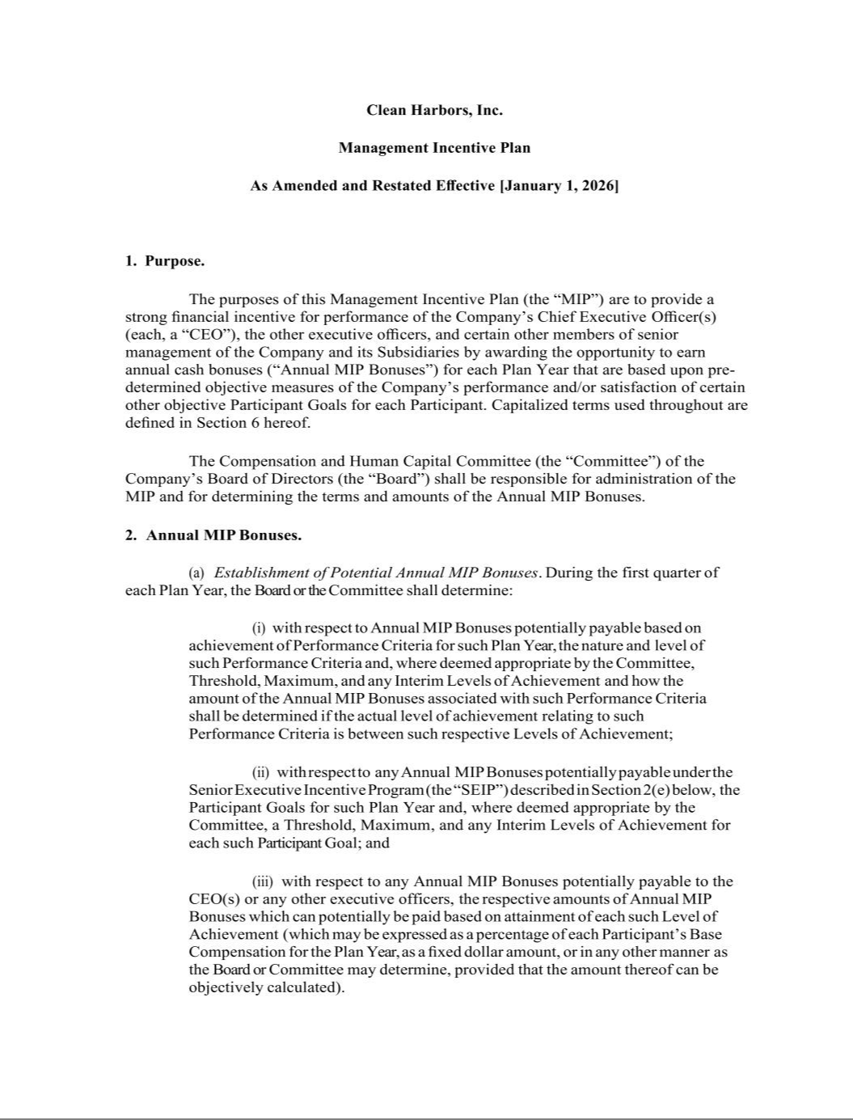

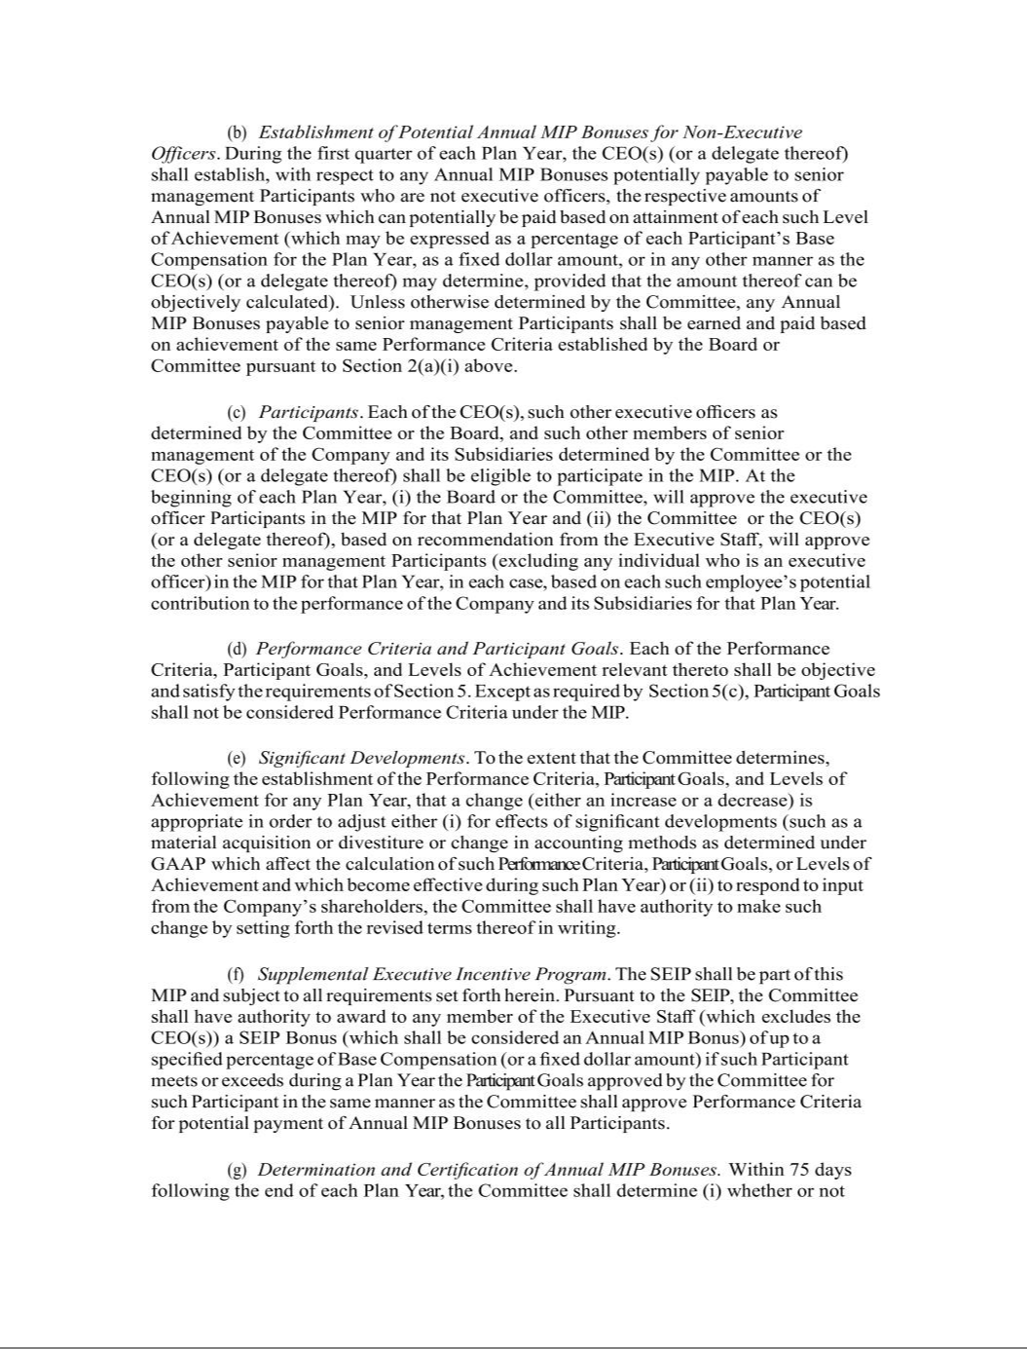

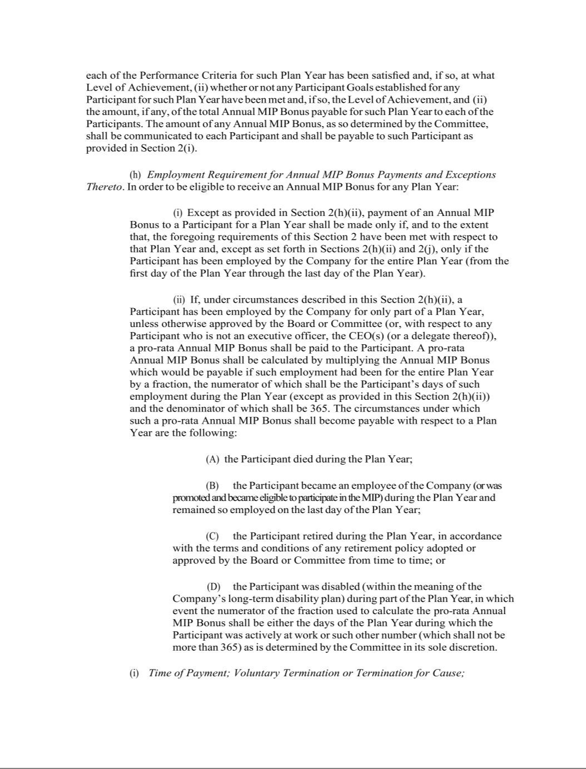

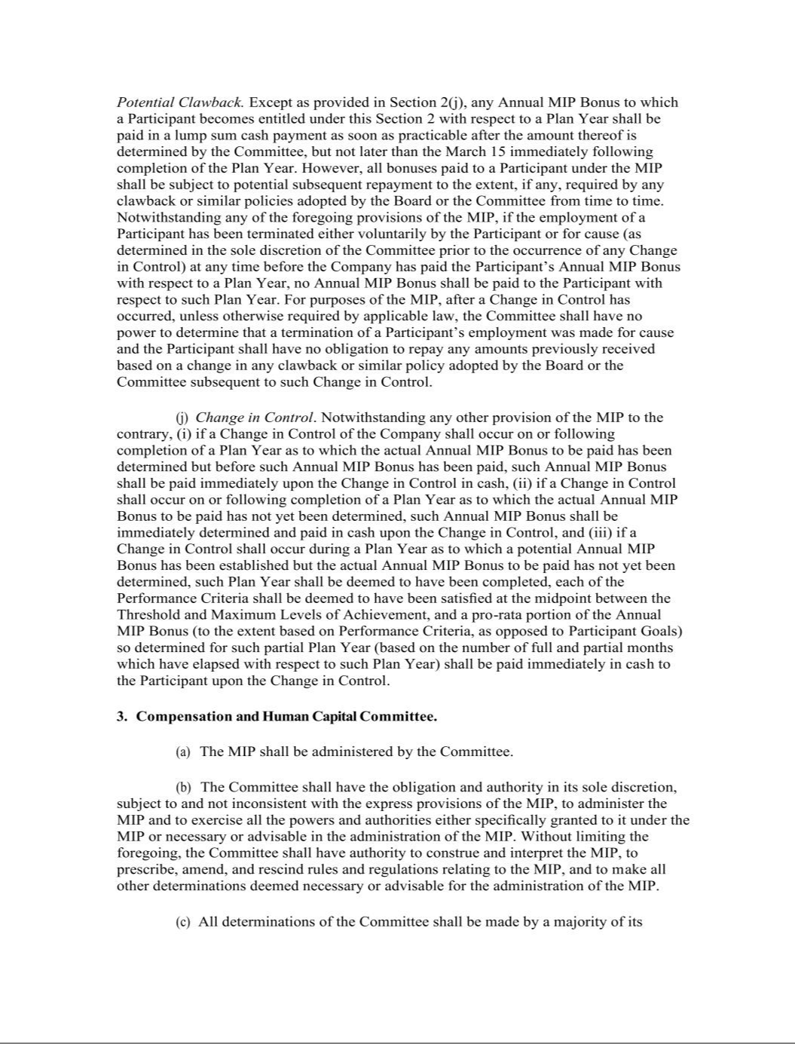

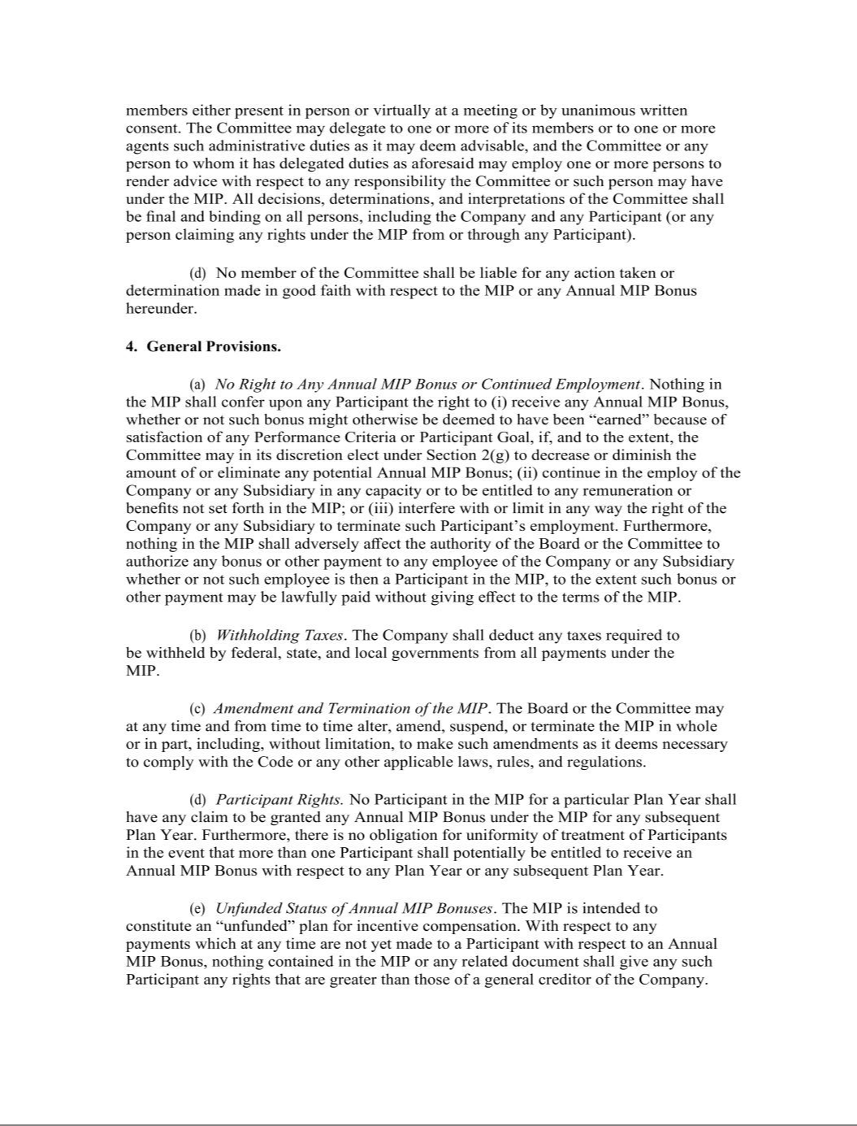

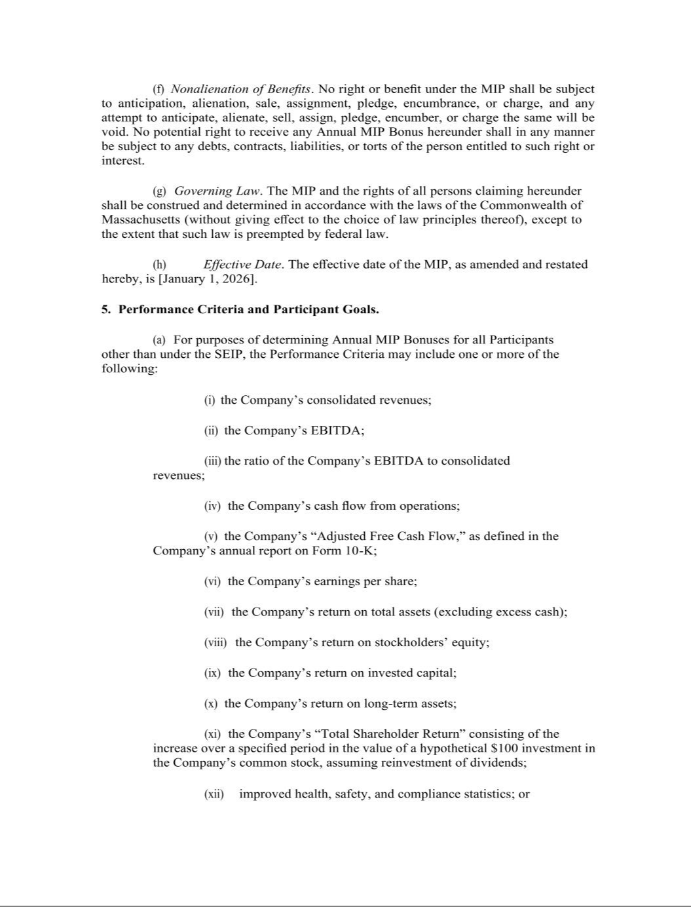

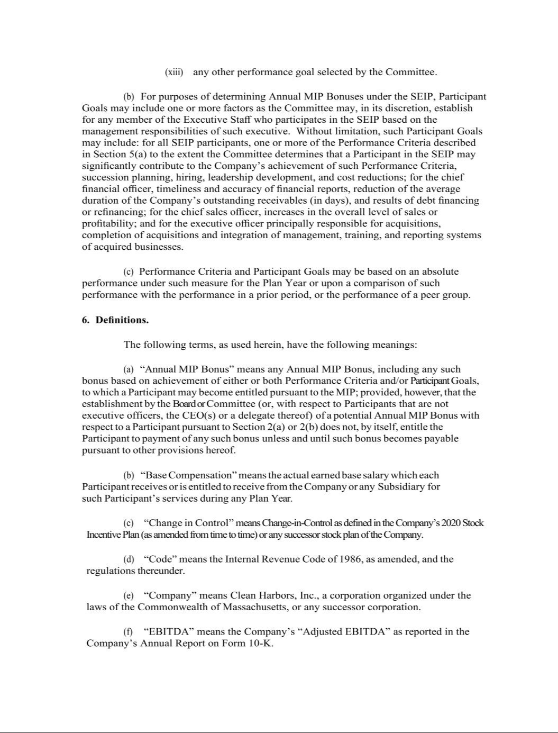

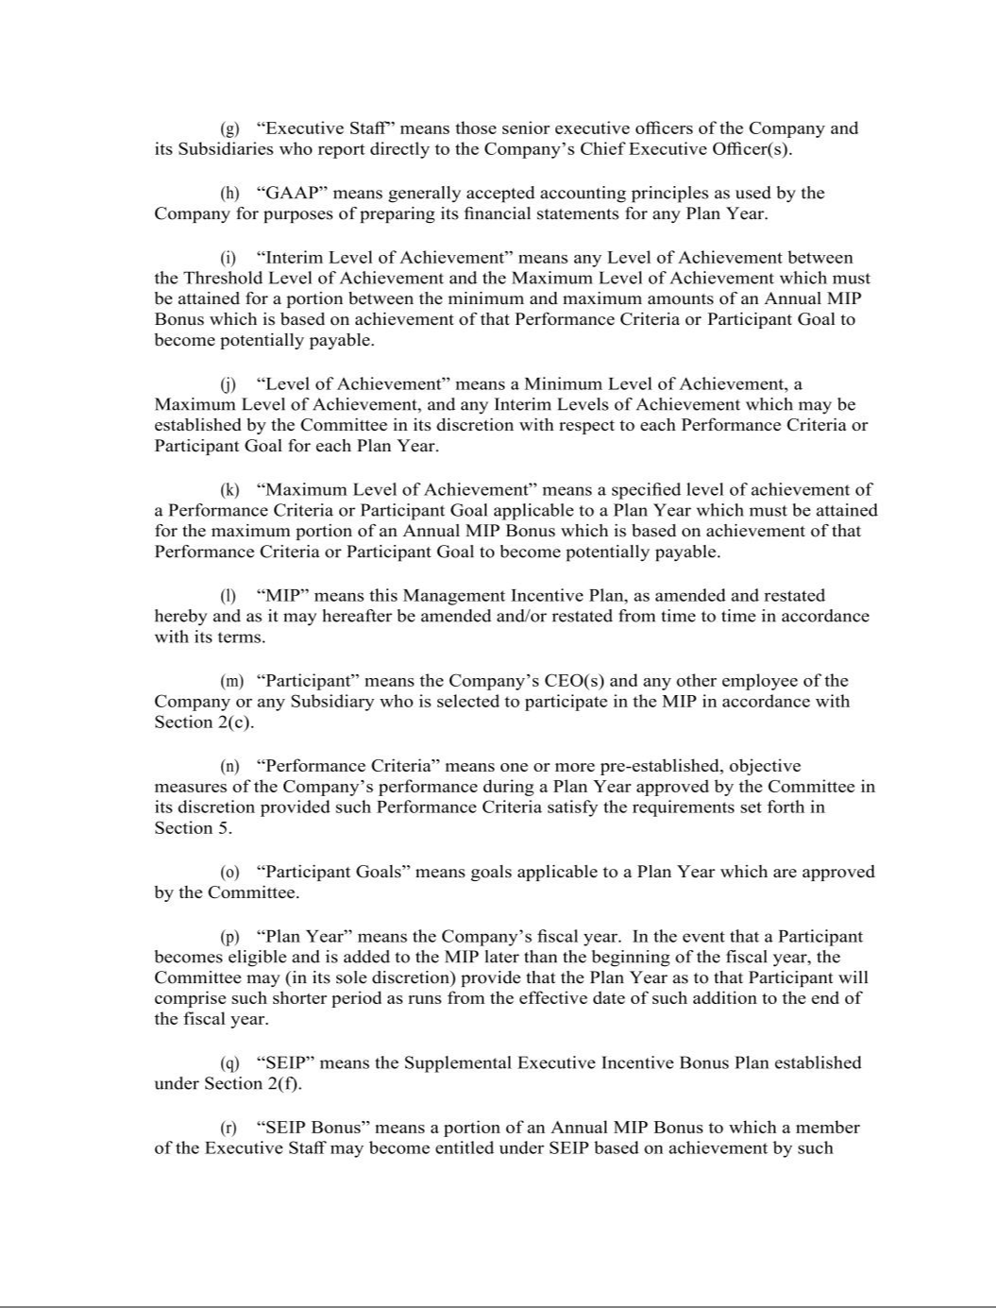

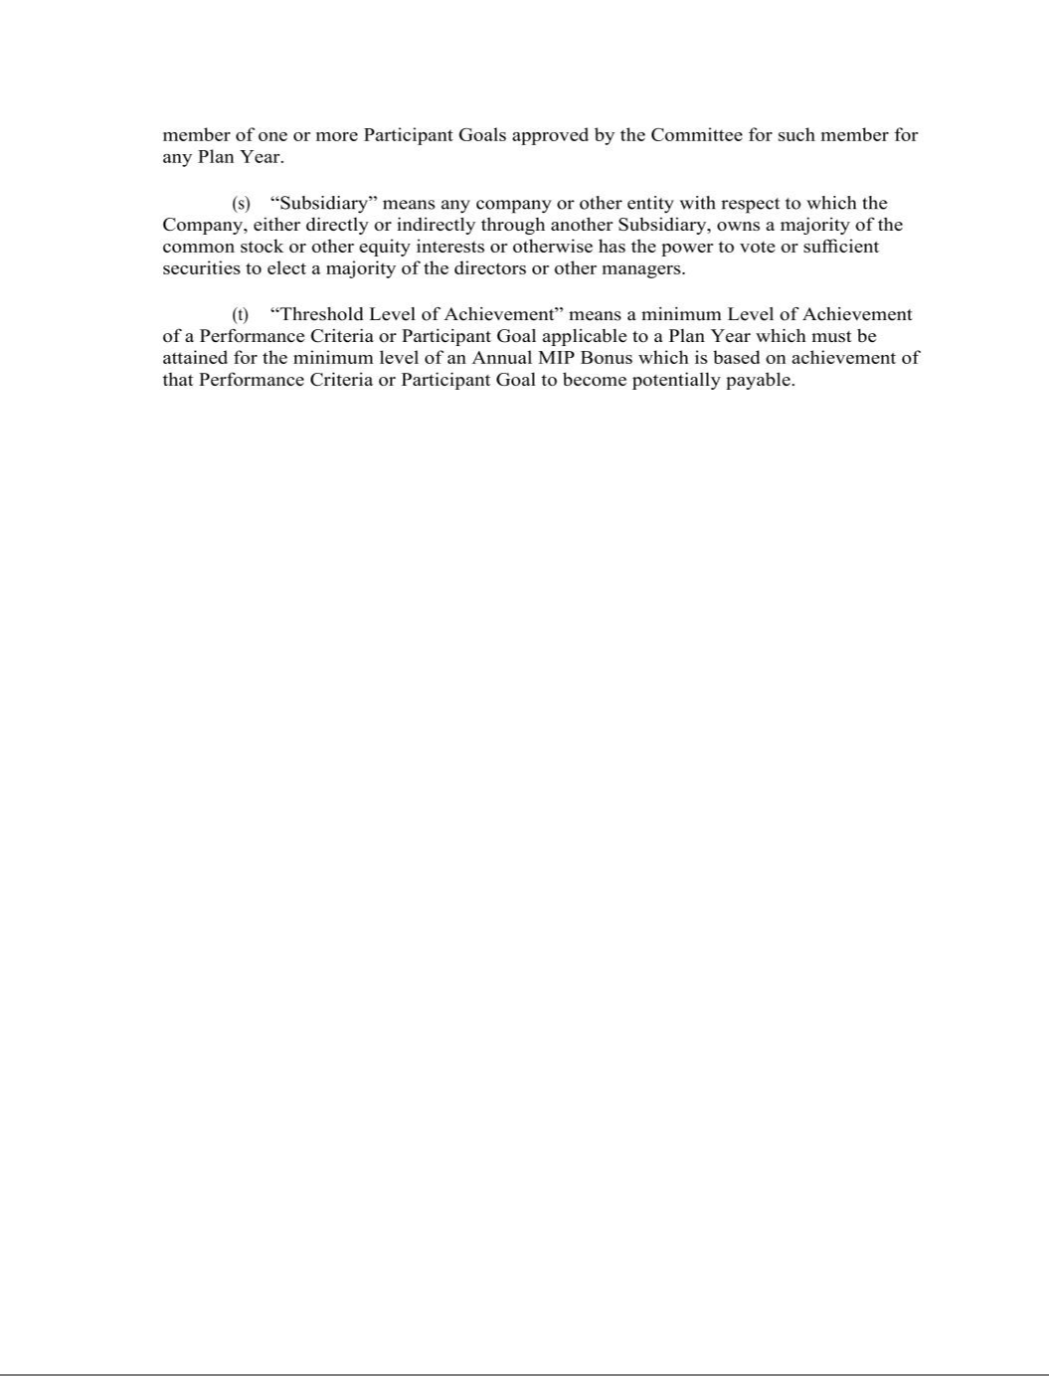

EXHIBIT 31.1

CERTIFICATION OF CO-CHIEF EXECUTIVE OFFICER

I, Michael L. Battles, certify that:

- I have reviewed this Quarterly Report on Form 10-Q of Clean Harbors, Inc.;

- Based on my knowledge, this report does not contain any untrue statement of a material fact or omit to state a material fact necessary to make the statements made, in light of the circumstances under which such statements were made, not misleading with respect to the period covered by this report;

- Based on my knowledge, the financial statements, and other financial information included in this report, fairly present in all material respects the financial condition, results of operations and cash flows of the registrant as of, and for, the periods presented in this report;

- The registrant’s other certifying officer(s) and I are responsible for establishing and maintaining disclosure controls and procedures (as defined in Exchange Act Rules 13a-15(e) and 15d-15(e)) and internal control over financial reporting (as defined in Exchange Act Rules 13a-15(f) and 15d-15(f)) for the registrant and have:

- Designed such disclosure controls and procedures, or caused such disclosure controls and procedures to be designed under our supervision, to ensure that material information relating to the registrant, including its consolidated subsidiaries, is made known to us by others within those entities, particularly during the period in which this report is being prepared;

- Designed such internal control over financial reporting, or caused such internal control over financial reporting to be designed under our supervision, to provide reasonable assurance regarding the reliability of financial reporting and the preparation of financial statements for external purposes in accordance with generally accepted accounting principles;

- Evaluated the effectiveness of the registrant’s disclosure controls and procedures and presented in this report our conclusions about the effectiveness of the disclosure controls and procedures, as of the end of the period covered by this report based on such evaluation; and

- Disclosed in this report any change in the registrant’s internal control over financial reporting that occurred during the registrant’s most recent fiscal quarter (the registrant’s fourth fiscal quarter in the case of an annual report) that has materially affected, or is reasonably likely to materially affect, the registrant’s internal control over financial reporting; and

- The registrant’s other certifying officer(s) and I have disclosed, based on our most recent evaluation of internal control over financial reporting, to the registrant’s auditors and the audit committee of the registrant’s board of directors (or persons performing the equivalent functions):

- All significant deficiencies and material weaknesses in the design or operation of internal control over financial reporting which are reasonably likely to adversely affect the registrant’s ability to record, process, summarize and report financial information; and

- Any fraud, whether or not material, that involves management or other employees who have a significant role in the registrant’s internal control over financial reporting.

/s/ MICHAEL L. BATTLES

Michael L. Battles

Co-Chief Executive Officer and Co-President

Date: October 29, 2025

EXHIBIT 31.2

CERTIFICATION OF CO-CHIEF EXECUTIVE OFFICER

I, Eric W. Gerstenberg, certify that:

- I have reviewed this Quarterly Report on Form 10-Q of Clean Harbors, Inc.;

- Based on my knowledge, this report does not contain any untrue statement of a material fact or omit to state a material fact necessary to make the statements made, in light of the circumstances under which such statements were made, not misleading with respect to the period covered by this report;

- Based on my knowledge, the financial statements, and other financial information included in this report, fairly present in all material respects the financial condition, results of operations and cash flows of the registrant as of, and for, the periods presented in this report;

- The registrant’s other certifying officer(s) and I are responsible for establishing and maintaining disclosure controls and procedures (as defined in Exchange Act Rules 13a-15(e) and 15d-15(e)) and internal control over financial reporting (as defined in Exchange Act Rules 13a-15(f) and 15d-15(f)) for the registrant and have:

- Designed such disclosure controls and procedures, or caused such disclosure controls and procedures to be designed under our supervision, to ensure that material information relating to the registrant, including its consolidated subsidiaries, is made known to us by others within those entities, particularly during the period in which this report is being prepared;

- Designed such internal control over financial reporting, or caused such internal control over financial reporting to be designed under our supervision, to provide reasonable assurance regarding the reliability of financial reporting and the preparation of financial statements for external purposes in accordance with generally accepted accounting principles;

- Evaluated the effectiveness of the registrant’s disclosure controls and procedures and presented in this report our conclusions about the effectiveness of the disclosure controls and procedures, as of the end of the period covered by this report based on such evaluation; and

- Disclosed in this report any change in the registrant’s internal control over financial reporting that occurred during the registrant’s most recent fiscal quarter (the registrant’s fourth fiscal quarter in the case of an annual report) that has materially affected, or is reasonably likely to materially affect, the registrant’s internal control over financial reporting; and

- The registrant’s other certifying officer(s) and I have disclosed, based on our most recent evaluation of internal control over financial reporting, to the registrant’s auditors and the audit committee of the registrant’s board of directors (or persons performing the equivalent functions):

- All significant deficiencies and material weaknesses in the design or operation of internal control over financial reporting which are reasonably likely to adversely affect the registrant’s ability to record, process, summarize and report financial information; and

- Any fraud, whether or not material, that involves management or other employees who have a significant role in the registrant’s internal control over financial reporting.

/s/ ERIC W. GERSTENBERG

Eric W. Gerstenberg

Co-Chief Executive Officer and Co-President

Date: October 29, 2025

EXHIBIT 31.3

CERTIFICATION OF CHIEF FINANCIAL OFFICER

I, Eric J. Dugas, certify that:

- I have reviewed this Quarterly Report on Form 10-Q of Clean Harbors, Inc.;

- Based on my knowledge, this report does not contain any untrue statement of a material fact or omit to state a material fact necessary to make the statements made, in light of the circumstances under which such statements were made, not misleading with respect to the period covered by this report;

- Based on my knowledge, the financial statements, and other financial information included in this report, fairly present in all material respects the financial condition, results of operations and cash flows of the registrant as of, and for, the periods presented in this report;

- The registrant’s other certifying officer(s) and I are responsible for establishing and maintaining disclosure controls and procedures (as defined in Exchange Act Rules 13a-15(e) and 15d-15(e)) and internal control over financial reporting (as defined in Exchange Act Rules 13a-15(f) and 15d-15(f)) for the registrant and have:

- Designed such disclosure controls and procedures, or caused such disclosure controls and procedures to be designed under our supervision, to ensure that material information relating to the registrant, including its consolidated subsidiaries, is made known to us by others within those entities, particularly during the period in which this report is being prepared;

- Designed such internal control over financial reporting, or caused such internal control over financial reporting to be designed under our supervision, to provide reasonable assurance regarding the reliability of financial reporting and the preparation of financial statements for external purposes in accordance with generally accepted accounting principles;

- Evaluated the effectiveness of the registrant’s disclosure controls and procedures and presented in this report our conclusions about the effectiveness of the disclosure controls and procedures, as of the end of the period covered by this report based on such evaluation; and

- Disclosed in this report any change in the registrant’s internal control over financial reporting that occurred during the registrant’s most recent fiscal quarter (the registrant’s fourth fiscal quarter in the case of an annual report) that has materially affected, or is reasonably likely to materially affect, the registrant’s internal control over financial reporting; and

- The registrant’s other certifying officer(s) and I have disclosed, based on our most recent evaluation of internal control over financial reporting, to the registrant’s auditors and the audit committee of the registrant’s board of directors (or persons performing the equivalent functions):

- All significant deficiencies and material weaknesses in the design or operation of internal control over financial reporting which are reasonably likely to adversely affect the registrant’s ability to record, process, summarize and report financial information; and

- Any fraud, whether or not material, that involves management or other employees who have a significant role in the registrant’s internal control over financial reporting.

/s/ ERIC J. DUGAS

Eric J. Dugas

Executive Vice President and Chief Financial Officer

Date: October 29, 2025

EXHIBIT 32

CLEAN HARBORS, INC. AND SUBSIDIARIES

CERTIFICATION PURSUANT TO

SECTION 1350, CHAPTER 63 OF TITLE 18, UNITED STATES CODE,

AS ADOPTED PURSUANT TO

SECTION 906 OF THE SARBANES OXLEY ACT OF 2002

Pursuant to 18 U.S.C. §1350, each of the undersigned certifies that, to his knowledge, this Quarterly Report on Form 10-Q for the period ended September 30, 2025 fully complies with the requirements of Section 13(a) or 15(d) of the Securities Exchange Act of 1934 and the information contained in this report fairly presents, in all material respects, the financial condition and results of operations of Clean Harbors, Inc.

By: | /s/ MICHAEL L. BATTLES
 | Michael L. Battles
Date: October 29, 2025 | Co-Chief Executive Officer and Co-President
By: | /s/ ERIC W. GERSTENBERG
 | Eric W. Gerstenberg
Date: October 29, 2025 | Co-Chief Executive Officer and Co-President
By: | /s/ ERIC J. DUGAS
 | Eric J. Dugas
Date: October 29, 2025 | Executive Vice President and Chief Financial Officer

